# Disclaimer

Please be advised that the numerical outputs presented herein are indicative of hypothetical model outputs and should be interpreted with caution. While diligent efforts have been made to incorporate a wide array of real-world variables that may influence the validity of these results, they are inherently subject to limitations inherent to predictive modelling.

It is imperative to understand that these measures should not be relied upon in isolation. They are intended to serve merely as one component within a broader, holistic assessment framework in decision-making processes. As such, these outputs should be regarded as provisional guides rather than definitive predictions.

Furthermore, potential users are encouraged to consult with relevant experts and consider additional sources of information when making decisions based on the data provided by this model. This model is best utilised as a supplementary tool to support, rather than replace, expert human judgement.

The developers of this model disclaim any liability for decisions made based on these model outputs alone. It is the responsibility of the user to ensure the appropriateness of the model’s application in any given circumstance.

Where solutions are focussed on a particular ICB Models are also generated whole region wide so where certain configurations may appear to attract more activity this may be activity from other regions.

# Methodology

We required an algorithm to address the objectives of our transformation program, recognizing the inherent limitations of a simple home to nearest site assignment which fails to balance other competing priorities.

This problem is akin to a variant of the traveling salesman problem (<https://en.wikipedia.org/wiki/Travelling_salesman_problem>), which is classified as NP-Hard and currently too computationally intensive to calculate all possible solutions and identify the optimally best solution directly. Thus, it necessitates the use of heuristic methods for practical resolution. In this context, we utilised a genetic algorithm to balance competing priorities effectively and derive a satisfactory solution.

An evolutionary algorithm is specifically designed to explore the entirety of potential solutions, evaluating each based on a custom fitness formula to achieve the objectives, and subsequently selecting the most idealised solution. The area of the search space where the most optimised solutions are found is known as the Pareto Front. Given that our objectives are distinctly specified, and we are implementing particular outcome goals for the evolution, we adopted an adaptive base mutation rate based on the stagnation observed in both the size and diversity of the Pareto Front.

The cessation of the process is also dictated by stagnation in the Pareto Front; once the mutation rate has been escalated without any noticeable improvements in size and diversity, the process was halted.

Our population, generations, and breeding processes are managed using the DEAP python library. However we developed our own custom function to assess the fitness of each solution. These scores are then leveraged to identify the best individual solutions in each generation, which are subsequently bred and mutated in future generations to evolve the population toward an effective solution for our problem with competing priorities.

Additionally, we crafted a custom mutation function to align mutations with a probabilistic distribution that mirrors the site assignment in the source data from home to the nearest site, the next nearest, and so on. This was necessary, after initial testing results, to ensure that the evolutionary algorithm explored viable areas of the search space that reflect real-world conditions rather than highly abstracted and impractical solutions.

These primary fitness tests were designed to mirror those outlined in the National Institute for Health Research paper Villeneuve E, Landa P, Allen M, Spencer A, Prosser S, Gibson A, et al. A framework to address key issues of neonatal service configuration in England: The NeoNet multimethod study. Health Serv Deliv Res 2018;6(35): <https://www.journalslibrary.nihr.ac.uk/hsdr/hsdr06350/#/abstract>

The competing objectives were as follows:

* Minimise the average travel time

* Maximise the proportion within 30 minutes

* Minimise the maximum distance for any assignment

* Maximise the number taking place in units with more than x admissions per year

* Maximise the smallest number of admissions per year

* Minimise the largest number of admissions per year

* Maximise the proportion within 30 minutes and in units with more than x admissions per year

For our specific application concerning critical care, rather than admissions data, we assessed whether NICU, LNU, and SCBU sites met the minimum required number of days as outlined in the BAPM standards. https://hubble-live-assets.s3.amazonaws.com/bapm/file_asset/file/1494/BAPM_Service_Quality_Standards_FINAL.pdf

We also considered the proportion of activities taking place in the most specialised NICU sites as a general positive.

Our adjusted objectives:

* Minimise the average travel time

* Maximise the proportion within 30 minutes

* Minimise the maximum distance for any assignment

* Maximise the number taking place in level 3 NICU units

* Maximise the smallest number of admissions per year

* Minimise the largest number of admissions per year

* Maximise the proportion within 30 minutes and in in level 3 NICU units

Given the disparity observed between the model's distribution and real-world data, we introduced an eighth objective to our model to encourage the formation of larger, more specialised centres. This involved summing the activities assigned to each site, calculating the standard deviations between these totals, and incorporating an objective to maximise this variance in the preferred solutions, thus directing the algorithm to prioritise solutions with greater variation between site sizes. This modification enhanced the performance of the algorithm in generating solutions that more accurately reflected the real-world distribution of activity. However it is important to note that, this tendency was still noticeable and therefore it was important to correct for this when analysing the results in respect of the targeted objective runs, we performed using the evolutionary tool.

The process was expedited by inserting extreme individuals into the initial population, based on the original data and a random distribution of home-to-site assignments consistent with the data. This optimization facilitated multiple runs of the algorithm to generate realistic scenarios. By adding these individuals, the algorithm received a jump start on viable genetic material, aiding in the exploration of useful areas of the search space.

We were able to add supplementary objectives to certain sites by imposing penalties on the evaluation function when objectives were not met, which, in some instances, significantly degraded the performance of the algorithm. To counteract this, we extended the mutation function to force the algorithm to focus on areas of the search space that would yield valid, non-penalised solutions. This approach enabled us to generate stochastic optimised solutions for a variety of targeted scenarios.

The process was executed eight times under various settings using elitism (pre-selecting the top 10 individuals from each generation for inclusion in the next), along with a combination of the Non-dominated Sorting Genetic Algorithm II (NSGA-II) and NSGA-III, and differing approaches to mutation. Results were then averaged to smooth the stochastic variability in the outputs.

# Initial Modelling High Level Analysis

# The core modelling outputs exhibited a marked tendency to distribute activities more broadly than is observed in the original site assignments in the data, as depicted in the graphic below concerning NICU activity.

# 

This suggests that the algorithm favoured site configurations where activity was shifted away from sites significantly exceeding the NICU activity standards and moved closer to the patients' home locations. The standard deviations and site groupings illustrated below demonstrate how this tendency manifests:

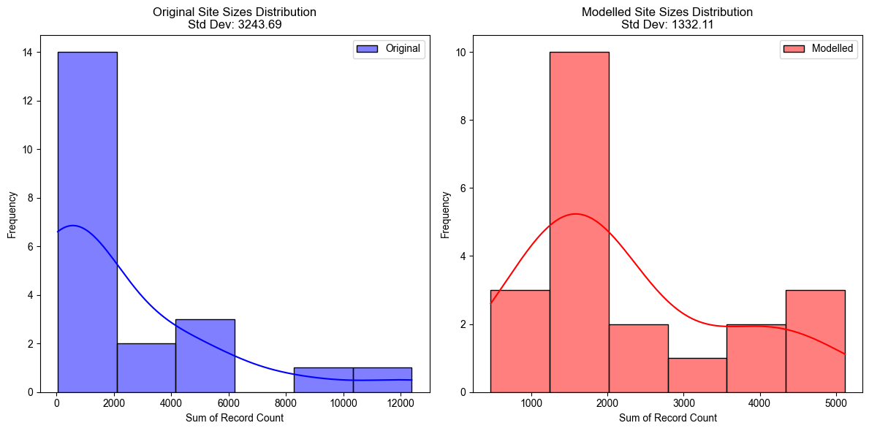

# It is crucial to recognise that these idealised results do not consider the current site configurations, or the challenges associated with implementing such radical transformations. Moreover, it was observed that even though the activity levels at smaller sites were notably enhanced, they frequently fell short of meeting the BAPM standards for Level 3 units. Understanding this tendency was essential, and we made adjustments in our final analysis to ensure the modelling outputs are appropriately used for decision support purposes.

# Decision Support Site Specific Objectives Analysis

We wanted to use the modelling to test certain specific site configurations in order that we could leverage its ability to replicate the stochasticity of real-world patient flows for decision support analysis. To do this we added a penalty function as previously described to force the modelling to explore areas of the search space that contain solutions that meet our specific objectives. These objectives are related to the BAPM activity standards and involve restricting or increasing the flow of NICU activity to particular sites. As we can merely incentivise the model in each run, and we expect results to be in a spectrum of more or less successfully met objectives, we chose figures derived from the BAPM service quality standards <https://hubble-live-assets.s3.eu-west-1.amazonaws.com/bapm/file_asset/file/1494/BAPM_Service_Quality_Standards_FINAL.pdf>. In which it recommends:

* LNUs over 600 Intensive Care days advised to have dedicated tier 3 resource.
* LNUs over 400 Intensive Care days advised to have dedicated tier 2 resource.

So we surmised that the idealised tier 2 should have between 600 and 400 NICU days, and where modelling for tier 1 we disincentivised models where site had no greater than 400 NICU activity. In some cases the model struggled to send sufficient activity to tier 3 sites where it would run counter to the main objectives and as such to create tier 3 resource in our objective specific models, we incentivised solutions where the site had over 1000 NICU days. While short of the idealised standard this produced better results alongside the primary parameters.

For these decision support purposes, in our analysis of the resulting solutions, it was necessary to include adjustments to account for the idealised modelling objectives. As the algorithm was pushed to explore more extreme solutions with very specific goals at certain sites—for example, restricting certain activities to not exceed predefined thresholds at a particular unit—it became essential to understand these adjustments and how they related to the actual data. We achieved this by calculating an average variance factor between the source data site assignments and the runs of the evolutionary algorithm with no specific additional objectives, thereby quantifying the effect of the primary fitness tests on the modelling.

Data from two key operational metrics—travel times and healthcare resource utilization (adjusted activity and NICU bed counts)—were scrutinised to identify patterns and significant deviations across various solutions and sites. The dataset was filtered to focus exclusively on this each specific region, ensuring relevance and precision in the insights derived.

The approach began by structuring the data into a format that facilitated comparison across multiple dimensions. For travel times, data was grouped by solution number, site, and IMD Decile, allowing the analysis to not only calculate the average travel times for each solution but also to examine how these times correlated with socio-economic factors defined by IMD classifications.

Parallel to the travel time analysis, we also explored the healthcare resource metrics, specifically modelled adjusted activity numbers and resulting NICU bed counts. The data for these metrics was similarly grouped by solution number and site, and mean values were calculated to serve as a baseline for comparison. Significant deviations from these site averages were identified through the calculation of percentage differences, with the top quartile set as the threshold for significance. This dynamic thresholding was crucial in pinpointing the most pronounced discrepancies, which might indicate areas requiring attention.

By employing statistical tests to validate the significance of observed variations, we ensured that the highlighted differences were not products of random chance. This rigorous methodology enabled a focused identification of areas where operational adjustments were necessary, guiding decision-making processes. The results from this comprehensive analysis provide multi-faceted insights, illustrating not only how travel times and activity varied by site and socio-economic factors but also identifying specific objectives that deviated significantly.

In order to focus the analysis on more modelling runs more representative of the real-world distribution for decision support purposes we focused the analysis on the subset of modelling runs using the weighted mutation function.

What follows is the resulting high level key points from this analysis grouped by region:

# Cheshire and Merseyside Objectives:

**Solution 17 Significant Deviations: Arrowe Park (Wirral) restricted to tier 1.**

Site: Arrowe Park Hospital

Adjusted Activity: 1073.00, Deviation: -47.26%

NICU Beds: 2.94, Deviation: -47.23%

Site: Countess of Chester Hospital

Adjusted Activity: 199.00, Deviation: 15.75%

NICU Beds: 0.55, Deviation: 15.82%

Site: Liverpool Women’s Hospital

Adjusted Activity: 5496.00, Deviation: -17.75%

NICU Beds: 15.06, Deviation: -17.75%

Average travel time: 23.87 minutes, ranked 6 among all solutions.

Trend in IMD Deciles: Travel times are shorter at lower IMD deciles, correlation coefficient 0.19.

Top 5 most negatively affected IMD Deciles with Actual Times:

- Leighton Hospital in IMD decile 4 with a mean travel time of 31.12 minutes.

- Macclesfield Hospital in IMD decile 2 with a mean travel time of 30.75 minutes.

- Macclesfield Hospital in IMD decile 5 with a mean travel time of 28.39 minutes.

- Leighton Hospital in IMD decile 9 with a mean travel time of 29.81 minutes.

- Countess of Chester Hospital in IMD decile 2 with a mean travel time of 19.86 minutes.

Top 5 most positively affected IMD Deciles with Actual Times:

- Countess of Chester Hospital in IMD decile 5 with a mean travel time of 26.66 minutes.

- Arrowe Park Hospital in IMD decile 10 with a mean travel time of 28.29 minutes.

- Arrowe Park Hospital in IMD decile 7 with a mean travel time of 23.09 minutes.

- Liverpool Women’s Hospital in IMD decile 10 with a mean travel time of 36.81 minutes.

- Leighton Hospital in IMD decile 6 with a mean travel time of 20.88 minutes.

The difference from the overall mean is statistically not significant (t-statistic = -0.18, p-value = 0.857).

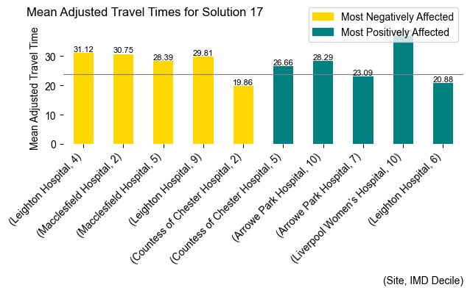

**Solution 18 Significant Deviations: COC restricted to tier 1.**

Site: Arrowe Park Hospital

Adjusted Activity: 2333.00, Deviation: 14.68%

NICU Beds: 6.39, Deviation: 14.66%

Site: Countess of Chester Hospital

Adjusted Activity: 64.00, Deviation: -62.77%

NICU Beds: 0.18, Deviation: -62.84%

Site: Macclesfield Hospital

Adjusted Activity: 324.00, Deviation: -11.01%

NICU Beds: 0.89, Deviation: -10.93%

Site: Whiston Hospital

Adjusted Activity: 440.00, Deviation: -9.71%

NICU Beds: 1.21, Deviation: -9.65%

Average travel time: 23.76 minutes, ranked 5 among all solutions.

Trend in IMD Deciles: Travel times are shorter at lower IMD deciles, correlation coefficient 0.20.

Top 5 most negatively affected IMD Deciles with Actual Times:

- Macclesfield Hospital in IMD decile 6 with a mean travel time of 35.37 minutes.

- Arrowe Park Hospital in IMD decile 8 with a mean travel time of 58.40 minutes.

- Arrowe Park Hospital in IMD decile 6 with a mean travel time of 55.56 minutes.

- Liverpool Women’s Hospital in IMD decile 5 with a mean travel time of 39.63 minutes.

- Ormskirk Hospital in IMD decile 10 with a mean travel time of 24.38 minutes.

Top 5 most positively affected IMD Deciles with Actual Times:

- Countess of Chester Hospital in IMD decile 2 with a mean travel time of 4.50 minutes.

- Countess of Chester Hospital in IMD decile 6 with a mean travel time of 29.77 minutes.

- Macclesfield Hospital in IMD decile 5 with a mean travel time of 17.32 minutes.

- Whiston Hospital in IMD decile 10 with a mean travel time of 27.85 minutes.

- Macclesfield Hospital in IMD decile 9 with a mean travel time of 21.07 minutes.

The difference from the overall mean is statistically not significant (t-statistic = -0.26, p-value = 0.798).

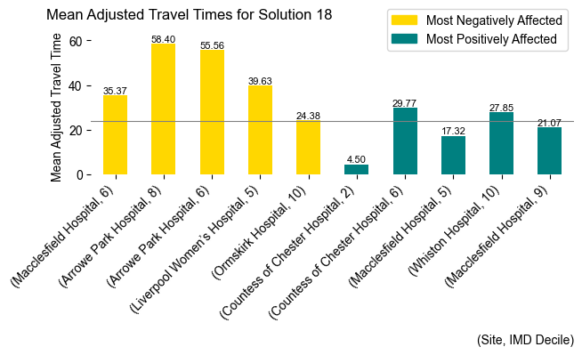

**Solution 19 Significant Deviations: Arrowe Park (Wirral) removed.**

Site: Countess of Chester Hospital

Adjusted Activity: 207.00, Deviation: 20.41%

NICU Beds: 0.57, Deviation: 20.32%

Site: Liverpool Women’s Hospital

Adjusted Activity: 8266.00, Deviation: 23.70%

NICU Beds: 22.65, Deviation: 23.69%

Site: Macclesfield Hospital

Adjusted Activity: 326.00, Deviation: -10.46%

NICU Beds: 0.89, Deviation: -10.45%

Site: Whiston Hospital

Adjusted Activity: 429.00, Deviation: -11.97%

NICU Beds: 1.18, Deviation: -11.91%

Average travel time: 22.56 minutes, ranked 1 among all solutions.

Trend in IMD Deciles: Travel times are shorter at lower IMD deciles, correlation coefficient 0.12.

Top 5 most negatively affected IMD Deciles with Actual Times:

- Whiston Hospital in IMD decile 8 with a mean travel time of 37.30 minutes.

- Leighton Hospital in IMD decile 4 with a mean travel time of 31.51 minutes.

- Liverpool Women’s Hospital in IMD decile 8 with a mean travel time of 40.02 minutes.

- Countess of Chester Hospital in IMD decile 2 with a mean travel time of 19.67 minutes.

- Warrington Hospital in IMD decile 5 with a mean travel time of 25.67 minutes.

Top 5 most positively affected IMD Deciles with Actual Times:

- Macclesfield Hospital in IMD decile 5 with a mean travel time of 9.02 minutes.

- Countess of Chester Hospital in IMD decile 6 with a mean travel time of 31.70 minutes.

- Liverpool Women’s Hospital in IMD decile 9 with a mean travel time of 36.16 minutes.

- Countess of Chester Hospital in IMD decile 5 with a mean travel time of 30.96 minutes.

- Ormskirk Hospital in IMD decile 10 with a mean travel time of 15.75 minutes.

The difference from the overall mean is statistically not significant (t-statistic = -1.38, p-value = 0.171).

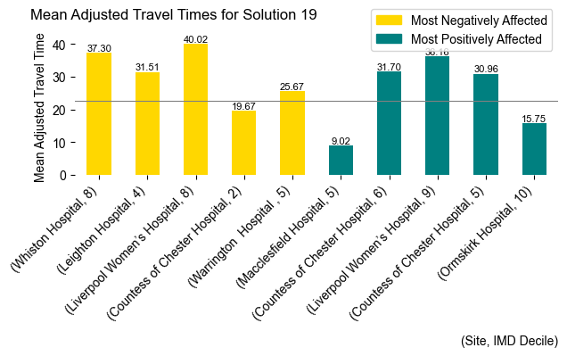

**Solution 20 Significant Deviations: Arrowe Park (Wirral) removed.**

Site: Arrowe Park Hospital

Adjusted Activity: 3243.00, Deviation: 59.41%

NICU Beds: 8.89, Deviation: 59.41%

Site: Macclesfield Hospital

Adjusted Activity: 330.00, Deviation: -9.36%

NICU Beds: 0.90, Deviation: -9.49%

Site: Ormskirk Hospital

Adjusted Activity: 329.00, Deviation: -7.30%

NICU Beds: 0.90, Deviation: -7.21%

Site: Whiston Hospital

Adjusted Activity: 422.00, Deviation: -13.41%

NICU Beds: 1.16, Deviation: -13.45%

Average travel time: 25.49 minutes, ranked 12 among all solutions.

Trend in IMD Deciles: Travel times are shorter at lower IMD deciles, correlation coefficient 0.47.

Top 5 most negatively affected IMD Deciles with Actual Times:

- Arrowe Park Hospital in IMD decile 8 with a mean travel time of 76.91 minutes.

- Liverpool Women’s Hospital in IMD decile 9 with a mean travel time of 54.68 minutes.

- Arrowe Park Hospital in IMD decile 6 with a mean travel time of 57.28 minutes.

- Arrowe Park Hospital in IMD decile 9 with a mean travel time of 35.56 minutes.

- Arrowe Park Hospital in IMD decile 7 with a mean travel time of 36.52 minutes.

Top 5 most positively affected IMD Deciles with Actual Times:

- Liverpool Women’s Hospital in IMD decile 5 with a mean travel time of 29.52 minutes.

- Macclesfield Hospital in IMD decile 3 with a mean travel time of 16.98 minutes.

- Leighton Hospital in IMD decile 1 with a mean travel time of 17.24 minutes.

- Warrington Hospital in IMD decile 5 with a mean travel time of 17.78 minutes.

- Macclesfield Hospital in IMD decile 2 with a mean travel time of 21.45 minutes.

The difference from the overall mean is statistically not significant (t-statistic = 1.02, p-value = 0.310).

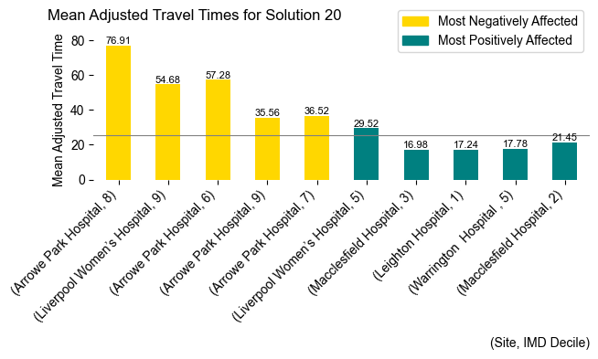

**Solution 21 Significant Deviations: Warrington restricted to tier 1.**

Site: Warrington Hospital

Adjusted Activity: 288.00, Deviation: -56.82%

NICU Beds: 0.79, Deviation: -56.73%

Site: Whiston Hospital

Adjusted Activity: 522.00, Deviation: 7.11%

NICU Beds: 1.43, Deviation: 7.22%

Average travel time: 23.33 minutes, ranked 3 among all solutions.

Trend in IMD Deciles: Travel times are shorter at lower IMD deciles, correlation coefficient 0.05.

Top 5 most negatively affected IMD Deciles with Actual Times:

- Whiston Hospital in IMD decile 5 with a mean travel time of 27.62 minutes.

- Liverpool Women’s Hospital in IMD decile 7 with a mean travel time of 41.05 minutes.

- Arrowe Park Hospital in IMD decile 10 with a mean travel time of 40.52 minutes.

- Liverpool Women’s Hospital in IMD decile 4 with a mean travel time of 49.29 minutes.

- Arrowe Park Hospital in IMD decile 8 with a mean travel time of 49.31 minutes.

Top 5 most positively affected IMD Deciles with Actual Times:

- Arrowe Park Hospital in IMD decile 6 with a mean travel time of 31.41 minutes.

- Macclesfield Hospital in IMD decile 6 with a mean travel time of 14.78 minutes.

- Countess of Chester Hospital in IMD decile 2 with a mean travel time of 7.37 minutes.

- Warrington Hospital in IMD decile 5 with a mean travel time of 14.79 minutes.

- Warrington Hospital in IMD decile 7 with a mean travel time of 12.72 minutes.

The difference from the overall mean is statistically not significant (t-statistic = -0.65, p-value = 0.516).

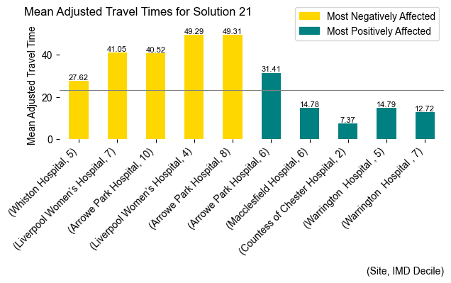

**Solution 22 Significant Deviations: Whiston restricted to tier 1.**

Site: Arrowe Park Hospital

Adjusted Activity: 1751.00, Deviation: -13.93%

NICU Beds: 4.80, Deviation: -13.91%

Site: Ormskirk Hospital

Adjusted Activity: 429.00, Deviation: 20.87%

NICU Beds: 1.18, Deviation: 20.94%

Site: Warrington Hospital

Adjusted Activity: 761.00, Deviation: 14.11%

NICU Beds: 2.08, Deviation: 14.05%

Site: Whiston Hospital

Adjusted Activity: 191.00, Deviation: -60.81%

NICU Beds: 0.52, Deviation: -60.83%

Average travel time: 22.82 minutes, ranked 2 among all solutions.

Trend in IMD Deciles: Travel times are shorter at lower IMD deciles, correlation coefficient 0.06.

Top 5 most negatively affected IMD Deciles with Actual Times:

- Macclesfield Hospital in IMD decile 3 with a mean travel time of 25.36 minutes.

- Liverpool Women’s Hospital in IMD decile 7 with a mean travel time of 39.12 minutes.

- Liverpool Women’s Hospital in IMD decile 8 with a mean travel time of 37.86 minutes.

- Countess of Chester Hospital in IMD decile 6 with a mean travel time of 40.09 minutes.

- Countess of Chester Hospital in IMD decile 10 with a mean travel time of 14.66 minutes.

Top 5 most positively affected IMD Deciles with Actual Times:

- Whiston Hospital in IMD decile 10 with a mean travel time of 17.63 minutes.

- Arrowe Park Hospital in IMD decile 6 with a mean travel time of 32.45 minutes.

- Macclesfield Hospital in IMD decile 6 with a mean travel time of 8.83 minutes.

- Whiston Hospital in IMD decile 9 with a mean travel time of 8.26 minutes.

- Macclesfield Hospital in IMD decile 1 with a mean travel time of 38.49 minutes.

The difference from the overall mean is statistically not significant (t-statistic = -1.23, p-value = 0.222).

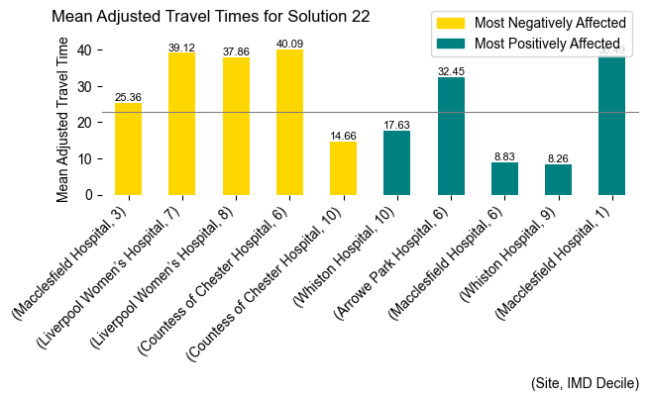

**Solution 23 Significant Deviations: Warrington removed.**

Site: Countess of Chester Hospital

Adjusted Activity: 153.00, Deviation: -11.00%

NICU Beds: 0.42, Deviation: -11.03%

Site: Leighton Hospital

Adjusted Activity: 404.00, Deviation: 7.95%

NICU Beds: 1.11, Deviation: 8.02%

Site: Macclesfield Hospital

Adjusted Activity: 328.00, Deviation: -9.91%

NICU Beds: 0.90, Deviation: -9.90%

Site: Whiston Hospital

Adjusted Activity: 602.00, Deviation: 23.53%

NICU Beds: 1.65, Deviation: 23.47%

Average travel time: 25.98 minutes, ranked 13 among all solutions.

Trend in IMD Deciles: Travel times are longer at lower IMD deciles, correlation coefficient -0.06.

Top 5 most negatively affected IMD Deciles with Actual Times:

- Countess of Chester Hospital in IMD decile 5 with a mean travel time of 55.83 minutes.

- Leighton Hospital in IMD decile 10 with a mean travel time of 46.17 minutes.

- Leighton Hospital in IMD decile 9 with a mean travel time of 32.29 minutes.

- Macclesfield Hospital in IMD decile 5 with a mean travel time of 29.43 minutes.

- Arrowe Park Hospital in IMD decile 2 with a mean travel time of 35.46 minutes.

Top 5 most positively affected IMD Deciles with Actual Times:

- Arrowe Park Hospital in IMD decile 6 with a mean travel time of 29.92 minutes.

- Macclesfield Hospital in IMD decile 8 with a mean travel time of 21.75 minutes.

- Macclesfield Hospital in IMD decile 6 with a mean travel time of 17.10 minutes.

- Arrowe Park Hospital in IMD decile 7 with a mean travel time of 25.26 minutes.

- Ormskirk Hospital in IMD decile 10 with a mean travel time of 16.50 minutes.

The difference from the overall mean is statistically not significant (t-statistic = 1.57, p-value = 0.120).

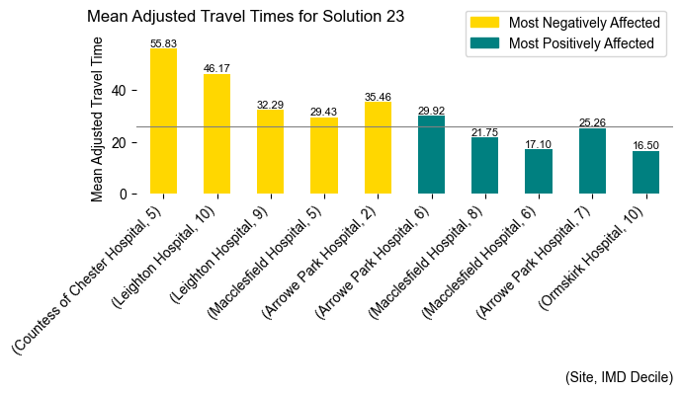

**Solution 24 Significant Deviations: Whiston removed.**

Site: Liverpool Women’s Hospital

Adjusted Activity: 8319.00, Deviation: 24.49%

NICU Beds: 22.79, Deviation: 24.49%

Site: Macclesfield Hospital

Adjusted Activity: 283.00, Deviation: -22.27%

NICU Beds: 0.78, Deviation: -22.17%

Site: Ormskirk Hospital

Adjusted Activity: 397.00, Deviation: 11.86%

NICU Beds: 1.09, Deviation: 11.86%

Site: Warrington Hospital

Adjusted Activity: 844.00, Deviation: 26.55%

NICU Beds: 2.31, Deviation: 26.52%

Average travel time: 24.54 minutes, ranked 9 among all solutions.

Trend in IMD Deciles: Travel times are shorter at lower IMD deciles, correlation coefficient 0.17.

Top 5 most negatively affected IMD Deciles with Actual Times:

- Arrowe Park Hospital in IMD decile 6 with a mean travel time of 51.35 minutes.

- Liverpool Women’s Hospital in IMD decile 9 with a mean travel time of 46.34 minutes.

- Liverpool Women’s Hospital in IMD decile 7 with a mean travel time of 40.59 minutes.

- Arrowe Park Hospital in IMD decile 7 with a mean travel time of 34.23 minutes.

- Liverpool Women’s Hospital in IMD decile 5 with a mean travel time of 38.17 minutes.

Top 5 most positively affected IMD Deciles with Actual Times:

- Arrowe Park Hospital in IMD decile 8 with a mean travel time of 37.34 minutes.

- Macclesfield Hospital in IMD decile 1 with a mean travel time of 40.28 minutes.

- Macclesfield Hospital in IMD decile 2 with a mean travel time of 19.19 minutes.

- Macclesfield Hospital in IMD decile 5 with a mean travel time of 18.10 minutes.

- Macclesfield Hospital in IMD decile 8 with a mean travel time of 24.33 minutes.

The difference from the overall mean is statistically not significant (t-statistic = 0.41, p-value = 0.681).

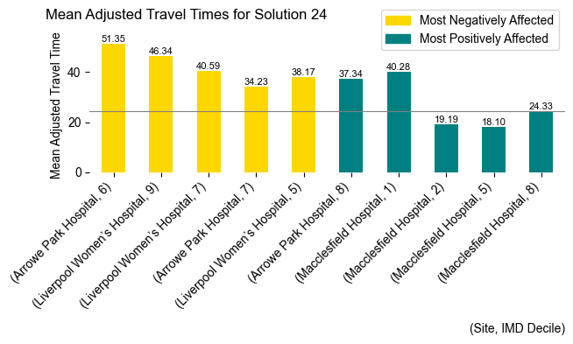

**Solution 25 Significant Deviations: Arrowe Park restricted to tier 2.**

Site: Arrowe Park Hospital

Adjusted Activity: 1430.00, Deviation: -29.71%

NICU Beds: 3.92, Deviation: -29.71%

Site: Countess of Chester Hospital

Adjusted Activity: 200.00, Deviation: 16.34%

NICU Beds: 0.55, Deviation: 16.55%

Site: Liverpool Women’s Hospital

Adjusted Activity: 5682.00, Deviation: -14.97%

NICU Beds: 15.57, Deviation: -14.97%

Site: Macclesfield Hospital

Adjusted Activity: 424.00, Deviation: 16.46%

NICU Beds: 1.16, Deviation: 16.50%

Site: Ormskirk Hospital

Adjusted Activity: 414.00, Deviation: 16.65%

NICU Beds: 1.14, Deviation: 16.71%

Site: Whiston Hospital

Adjusted Activity: 536.00, Deviation: 9.99%

NICU Beds: 1.47, Deviation: 9.93%

Average travel time: 23.69 minutes, ranked 4 among all solutions.

Trend in IMD Deciles: Travel times are shorter at lower IMD deciles, correlation coefficient 0.24.

Top 5 most negatively affected IMD Deciles with Actual Times:

- Countess of Chester Hospital in IMD decile 2 with a mean travel time of 19.31 minutes.

- Whiston Hospital in IMD decile 5 with a mean travel time of 26.71 minutes.

- Ormskirk Hospital in IMD decile 8 with a mean travel time of 19.70 minutes.

- Macclesfield Hospital in IMD decile 2 with a mean travel time of 27.85 minutes.

- Warrington Hospital in IMD decile 5 with a mean travel time of 24.06 minutes.

Top 5 most positively affected IMD Deciles with Actual Times:

- Arrowe Park Hospital in IMD decile 6 with a mean travel time of 39.37 minutes.

- Leighton Hospital in IMD decile 6 with a mean travel time of 21.07 minutes.

- Arrowe Park Hospital in IMD decile 5 with a mean travel time of 22.18 minutes.

- Liverpool Women’s Hospital in IMD decile 8 with a mean travel time of 30.24 minutes.

- Arrowe Park Hospital in IMD decile 10 with a mean travel time of 31.38 minutes.

The difference from the overall mean is statistically not significant (t-statistic = -0.37, p-value = 0.710).

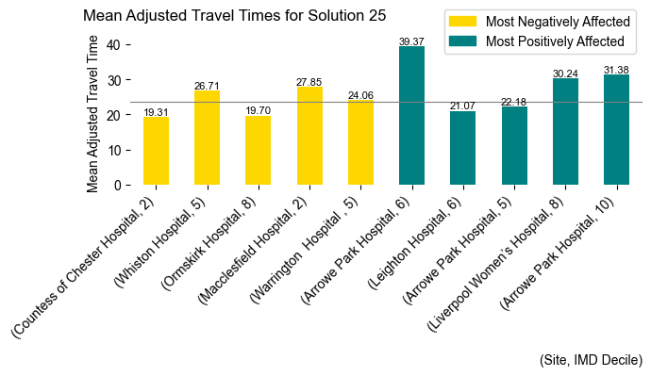

**Solution 37 Significant Deviations: Leighton removed.**

Site: Countess of Chester Hospital

Adjusted Activity: 238.00, Deviation: 38.44%

NICU Beds: 0.65, Deviation: 38.61%

Site: Liverpool Women’s Hospital

Adjusted Activity: 5369.00, Deviation: -19.66%

NICU Beds: 14.71, Deviation: -19.65%

Site: Macclesfield Hospital

Adjusted Activity: 574.00, Deviation: 57.66%

NICU Beds: 1.57, Deviation: 57.51%

Site: Whiston Hospital

Adjusted Activity: 548.00, Deviation: 12.45%

NICU Beds: 1.50, Deviation: 12.55%

Average travel time: 24.06 minutes, ranked 7 among all solutions.

Trend in IMD Deciles: Travel times are shorter at lower IMD deciles, correlation coefficient 0.20.

Top 5 most negatively affected IMD Deciles with Actual Times:

- Arrowe Park Hospital in IMD decile 4 with a mean travel time of 40.50 minutes.

- Arrowe Park Hospital in IMD decile 6 with a mean travel time of 58.16 minutes.

- Macclesfield Hospital in IMD decile 6 with a mean travel time of 33.57 minutes.

- Macclesfield Hospital in IMD decile 9 with a mean travel time of 35.80 minutes.

- Macclesfield Hospital in IMD decile 8 with a mean travel time of 38.34 minutes.

Top 5 most positively affected IMD Deciles with Actual Times:

- Liverpool Women’s Hospital in IMD decile 8 with a mean travel time of 26.02 minutes.

- Arrowe Park Hospital in IMD decile 8 with a mean travel time of 37.46 minutes.

- Macclesfield Hospital in IMD decile 1 with a mean travel time of 38.66 minutes.

- Liverpool Women’s Hospital in IMD decile 6 with a mean travel time of 31.73 minutes.

- Liverpool Women’s Hospital in IMD decile 3 with a mean travel time of 24.77 minutes.

The difference from the overall mean is statistically not significant (t-statistic = 0.01, p-value = 0.990).

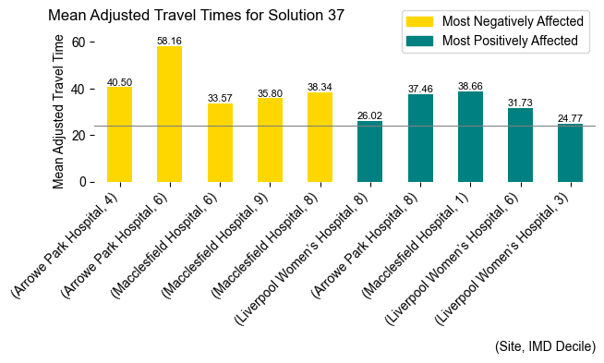

**Solution 38 Significant Deviations: Macclesfield removed.**

Site: Whiston Hospital

Adjusted Activity: 443.00, Deviation: -9.10%

NICU Beds: 1.21, Deviation: -9.09%

Average travel time: 24.47 minutes, ranked 8 among all solutions.

Trend in IMD Deciles: Travel times are longer at lower IMD deciles, correlation coefficient -0.02.

Top 5 most negatively affected IMD Deciles with Actual Times:

- Countess of Chester Hospital in IMD decile 6 with a mean travel time of 56.91 minutes.

- Countess of Chester Hospital in IMD decile 3 with a mean travel time of 29.70 minutes.

- Whiston Hospital in IMD decile 10 with a mean travel time of 37.53 minutes.

- Liverpool Women’s Hospital in IMD decile 10 with a mean travel time of 47.81 minutes.

- Liverpool Women’s Hospital in IMD decile 6 with a mean travel time of 43.87 minutes.

Top 5 most positively affected IMD Deciles with Actual Times:

- Arrowe Park Hospital in IMD decile 8 with a mean travel time of 31.52 minutes.

- Countess of Chester Hospital in IMD decile 5 with a mean travel time of 29.86 minutes.

- Whiston Hospital in IMD decile 8 with a mean travel time of 22.96 minutes.

- Liverpool Women’s Hospital in IMD decile 9 with a mean travel time of 37.87 minutes.

- Whiston Hospital in IMD decile 6 with a mean travel time of 21.32 minutes.

The difference from the overall mean is statistically not significant (t-statistic = 0.35, p-value = 0.730).

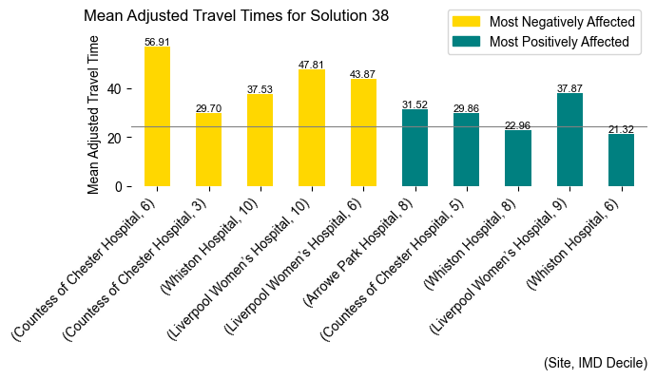

**Solution 39 Significant Deviations: Southport & Ormskirk restricted to tier 1.**

Site: Arrowe Park Hospital

Adjusted Activity: 2234.00, Deviation: 9.81%

NICU Beds: 6.12, Deviation: 9.79%

Site: Countess of Chester Hospital

Adjusted Activity: 153.00, Deviation: -11.00%

NICU Beds: 0.42, Deviation: -10.74%

Site: Liverpool Women’s Hospital

Adjusted Activity: 6200.00, Deviation: -7.22%

NICU Beds: 16.99, Deviation: -7.22%

Site: Ormskirk Hospital

Adjusted Activity: 208.00, Deviation: -41.39%

NICU Beds: 0.57, Deviation: -41.33%

Site: Whiston Hospital

Adjusted Activity: 564.00, Deviation: 15.73%

NICU Beds: 1.55, Deviation: 15.68%

Average travel time: 24.69 minutes, ranked 10 among all solutions.

Trend in IMD Deciles: Travel times are shorter at lower IMD deciles, correlation coefficient 0.14.

Top 5 most negatively affected IMD Deciles with Actual Times:

- Liverpool Women’s Hospital in IMD decile 10 with a mean travel time of 53.45 minutes.

- Macclesfield Hospital in IMD decile 7 with a mean travel time of 31.16 minutes.

- Arrowe Park Hospital in IMD decile 6 with a mean travel time of 54.73 minutes.

- Macclesfield Hospital in IMD decile 5 with a mean travel time of 31.00 minutes.

- Ormskirk Hospital in IMD decile 9 with a mean travel time of 28.23 minutes.

Top 5 most positively affected IMD Deciles with Actual Times:

- Countess of Chester Hospital in IMD decile 2 with a mean travel time of 5.55 minutes.

- Countess of Chester Hospital in IMD decile 6 with a mean travel time of 29.38 minutes.

- Countess of Chester Hospital in IMD decile 5 with a mean travel time of 31.14 minutes.

- Liverpool Women’s Hospital in IMD decile 7 with a mean travel time of 32.14 minutes.

- Countess of Chester Hospital in IMD decile 8 with a mean travel time of 13.19 minutes.

The difference from the overall mean is statistically not significant (t-statistic = 0.57, p-value = 0.569).

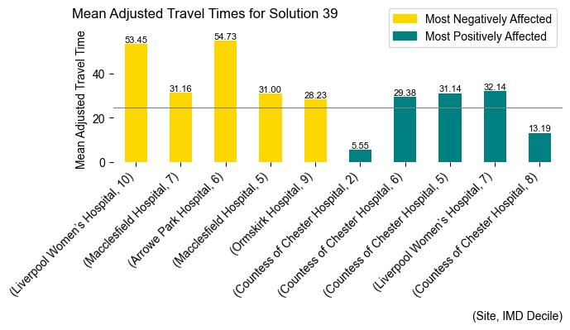

**Solution 40 Significant Deviations: Southport & Ormskirk removed.**

Site: Liverpool Women’s Hospital

Adjusted Activity: 7171.00, Deviation: 7.31%

NICU Beds: 19.65, Deviation: 7.31%

Site: Whiston Hospital

Adjusted Activity: 657.00, Deviation: 34.82%

NICU Beds: 1.80, Deviation: 34.75%

Average travel time: 25.41 minutes, ranked 11 among all solutions.

Trend in IMD Deciles: Travel times are shorter at lower IMD deciles, correlation coefficient 0.07.

Top 5 most negatively affected IMD Deciles with Actual Times:

- Macclesfield Hospital in IMD decile 1 with a mean travel time of 60.02 minutes.

- Liverpool Women’s Hospital in IMD decile 4 with a mean travel time of 52.36 minutes.

- Countess of Chester Hospital in IMD decile 2 with a mean travel time of 21.64 minutes.

- Whiston Hospital in IMD decile 6 with a mean travel time of 30.85 minutes.

- Whiston Hospital in IMD decile 5 with a mean travel time of 28.55 minutes.

Top 5 most positively affected IMD Deciles with Actual Times:

- Arrowe Park Hospital in IMD decile 4 with a mean travel time of 20.98 minutes.

- Macclesfield Hospital in IMD decile 6 with a mean travel time of 17.96 minutes.

- Arrowe Park Hospital in IMD decile 8 with a mean travel time of 41.07 minutes.

- Liverpool Women’s Hospital in IMD decile 10 with a mean travel time of 39.14 minutes.

- Macclesfield Hospital in IMD decile 2 with a mean travel time of 20.86 minutes.

The difference from the overall mean is statistically not significant (t-statistic = 1.10, p-value = 0.274).

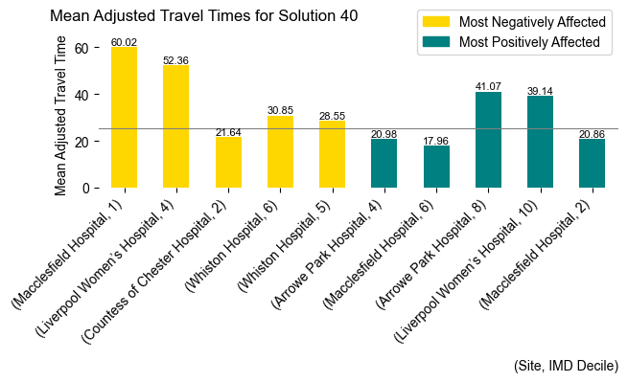

# Lancashire and South Cumbria

**Solution 2 Significant Deviations: Burnley tier 2 IC Days Limit.**

Site: Burnley Hospital

Adjusted Activity: 1680.00, Deviation: -53.24%

NICU Beds: 4.60, Deviation: -53.24%

Site: Royal Preston Hospital

Adjusted Activity: 3930.00, Deviation: 31.59%

NICU Beds: 10.77, Deviation: 31.57%

Average travel time: 26.56 minutes, ranked 10 among all solutions.

Trend in IMD Deciles: Travel times are longer at lower IMD deciles, correlation coefficient -0.19.

Top 5 most negatively affected IMD Deciles with Actual Times:

- Victoria Blackpool in IMD decile 10 with a mean travel time of 108.30 minutes.

- Victoria Blackpool in IMD decile 8 with a mean travel time of 38.50 minutes.

- Royal Preston Hospital in IMD decile 1 with a mean travel time of 46.54 minutes.

- Royal Preston Hospital in IMD decile 2 with a mean travel time of 48.71 minutes.

- Royal Lancaster Infirmary in IMD decile 1 with a mean travel time of 43.23 minutes.

Top 5 most positively affected IMD Deciles with Actual Times:

- Burnley Hospital in IMD decile 10 with a mean travel time of 28.76 minutes.

- Royal Lancaster Infirmary in IMD decile 10 with a mean travel time of 44.85 minutes.

- Burnley Hospital in IMD decile 5 with a mean travel time of 23.84 minutes.

- Furness General Hospital in IMD decile 2 with a mean travel time of 13.71 minutes.

- Royal Lancaster Infirmary in IMD decile 4 with a mean travel time of 10.92 minutes.

The difference from the overall mean is statistically not significant (t-statistic = 0.61, p-value = 0.548).

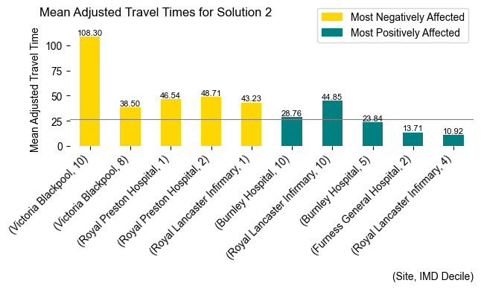

**Solution 3 Significant Deviations: Preston tier 2 IC Days Limit.**

Site: Burnley Hospital

Adjusted Activity: 4570.00, Deviation: 27.19%

NICU Beds: 12.52, Deviation: 27.20%

Site: Royal Preston Hospital

Adjusted Activity: 1392.00, Deviation: -53.39%

NICU Beds: 3.81, Deviation: -53.39%

Average travel time: 25.68 minutes, ranked 7 among all solutions.

Trend in IMD Deciles: Travel times are longer at lower IMD deciles, correlation coefficient -0.10.

Top 5 most negatively affected IMD Deciles with Actual Times:

- Furness General Hospital in IMD decile 2 with a mean travel time of 42.14 minutes.

- Royal Lancaster Infirmary in IMD decile 10 with a mean travel time of 73.09 minutes.

- Victoria Blackpool in IMD decile 6 with a mean travel time of 39.01 minutes.

- Burnley Hospital in IMD decile 7 with a mean travel time of 31.25 minutes.

- Burnley Hospital in IMD decile 1 with a mean travel time of 20.24 minutes.

Top 5 most positively affected IMD Deciles with Actual Times:

- Victoria Blackpool in IMD decile 10 with a mean travel time of 38.63 minutes.

- Royal Lancaster Infirmary in IMD decile 4 with a mean travel time of 9.07 minutes.

- Royal Preston Hospital in IMD decile 8 with a mean travel time of 28.61 minutes.

- Royal Preston Hospital in IMD decile 2 with a mean travel time of 35.19 minutes.

- Burnley Hospital in IMD decile 5 with a mean travel time of 25.54 minutes.

The difference from the overall mean is statistically not significant (t-statistic = 0.30, p-value = 0.767).

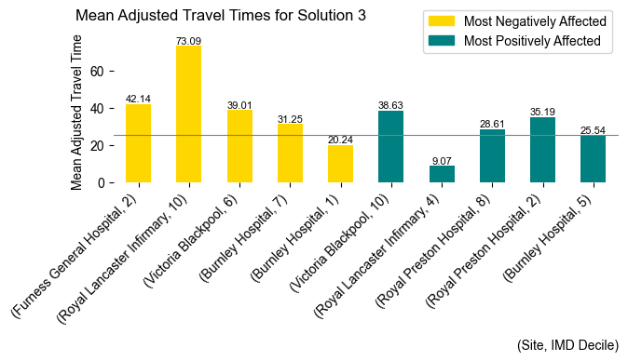

**Solution 4 Significant Deviations: Burnley tier 1 ICU Limit.**

Site: Burnley Hospital

Adjusted Activity: 1111.00, Deviation: -69.08%

NICU Beds: 3.04, Deviation: -69.08%

Site: Royal Preston Hospital

Adjusted Activity: 4396.00, Deviation: 47.19%

NICU Beds: 12.05, Deviation: 47.20%

Average travel time: 27.67 minutes, ranked 12 among all solutions.

Trend in IMD Deciles: Travel times are shorter at lower IMD deciles, correlation coefficient 0.20.

Top 5 most negatively affected IMD Deciles with Actual Times:

- Furness General Hospital in IMD decile 8 with a mean travel time of 62.61 minutes.

- Royal Lancaster Infirmary in IMD decile 10 with a mean travel time of 82.30 minutes.

- Victoria Blackpool in IMD decile 9 with a mean travel time of 37.92 minutes.

- Royal Preston Hospital in IMD decile 1 with a mean travel time of 49.91 minutes.

- Victoria Blackpool in IMD decile 8 with a mean travel time of 38.80 minutes.

Top 5 most positively affected IMD Deciles with Actual Times:

- Victoria Blackpool in IMD decile 10 with a mean travel time of 31.80 minutes.

- Royal Lancaster Infirmary in IMD decile 4 with a mean travel time of 10.27 minutes.

- Burnley Hospital in IMD decile 10 with a mean travel time of 34.62 minutes.

- Royal Lancaster Infirmary in IMD decile 2 with a mean travel time of 16.16 minutes.

- Burnley Hospital in IMD decile 9 with a mean travel time of 26.13 minutes.

The difference from the overall mean is statistically not significant (t-statistic = 1.21, p-value = 0.231).

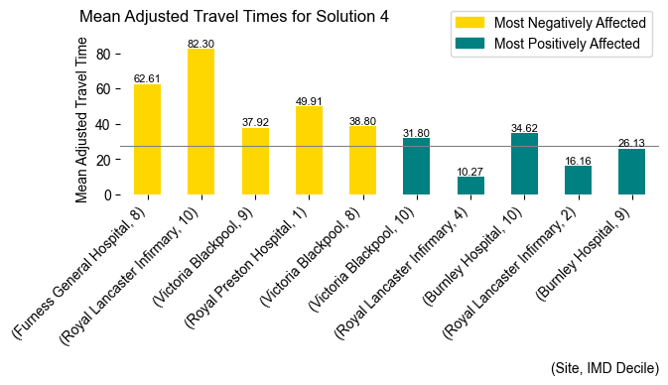

**Solution 5 Significant Deviations: Preston tier 1 ICU Limit.**

Site: Burnley Hospital

Adjusted Activity: 4549.00, Deviation: 26.61%

NICU Beds: 12.47, Deviation: 26.61%

Site: Royal Preston Hospital

Adjusted Activity: 1064.00, Deviation: -64.37%

NICU Beds: 2.92, Deviation: -64.35%

Average travel time: 26.84 minutes, ranked 11 among all solutions.

Trend in IMD Deciles: Travel times are shorter at lower IMD deciles, correlation coefficient 0.29.

Top 5 most negatively affected IMD Deciles with Actual Times:

- Furness General Hospital in IMD decile 7 with a mean travel time of 68.75 minutes.

- Furness General Hospital in IMD decile 3 with a mean travel time of 33.60 minutes.

- Royal Lancaster Infirmary in IMD decile 4 with a mean travel time of 29.23 minutes.

- Furness General Hospital in IMD decile 6 with a mean travel time of 23.89 minutes.

- Victoria Blackpool in IMD decile 3 with a mean travel time of 22.84 minutes.

Top 5 most positively affected IMD Deciles with Actual Times:

- Royal Lancaster Infirmary in IMD decile 10 with a mean travel time of 37.24 minutes.

- Furness General Hospital in IMD decile 8 with a mean travel time of 21.61 minutes.

- Furness General Hospital in IMD decile 2 with a mean travel time of 12.36 minutes.

- Royal Preston Hospital in IMD decile 5 with a mean travel time of 28.39 minutes.

- Royal Preston Hospital in IMD decile 8 with a mean travel time of 30.96 minutes.

The difference from the overall mean is statistically not significant (t-statistic = 1.09, p-value = 0.279).

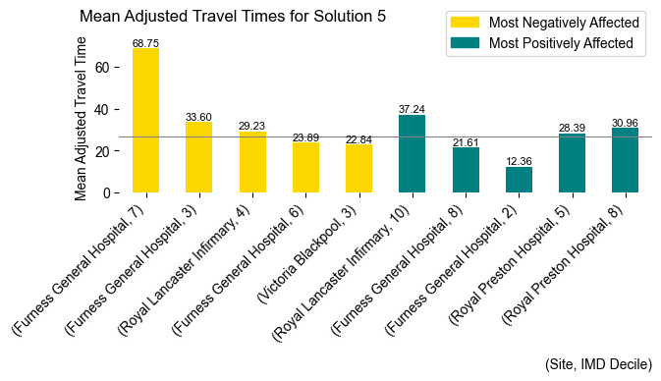

**Solution 6 Significant Deviations: Blackburn added as tier 3.**

Site: Furness General Hospital

Adjusted Activity: 39.00, Deviation: -26.20%

NICU Beds: 0.11, Deviation: -25.33%

Average travel time: 22.90 minutes, ranked 3 among all solutions.

Trend in IMD Deciles: Travel times are shorter at lower IMD deciles, correlation coefficient 0.42.

Top 5 most negatively affected IMD Deciles with Actual Times:

- Burnley Hospital in IMD decile 9 with a mean travel time of 42.58 minutes.

- Royal Blackburn Hospital in IMD decile 5 with a mean travel time of 29.52 minutes.

- Burnley Hospital in IMD decile 6 with a mean travel time of 27.17 minutes.

- Burnley Hospital in IMD decile 5 with a mean travel time of 33.40 minutes.

- Royal Preston Hospital in IMD decile 8 with a mean travel time of 37.94 minutes.

Top 5 most positively affected IMD Deciles with Actual Times:

- Victoria Blackpool in IMD decile 10 with a mean travel time of 25.60 minutes.

- Royal Lancaster Infirmary in IMD decile 1 with a mean travel time of 27.97 minutes.

- Royal Lancaster Infirmary in IMD decile 2 with a mean travel time of 13.80 minutes.

- Furness General Hospital in IMD decile 2 with a mean travel time of 13.66 minutes.

- Royal Lancaster Infirmary in IMD decile 6 with a mean travel time of 32.88 minutes.

The difference from the overall mean is statistically not significant (t-statistic = -1.80, p-value = 0.078).

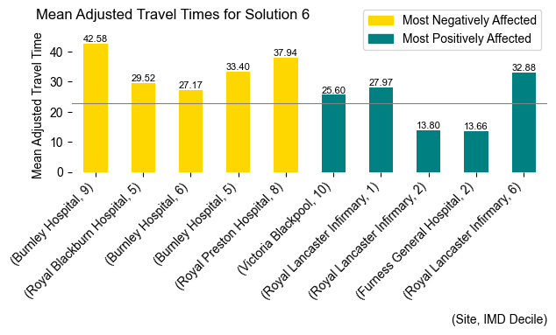

**Solution 7 Significant Deviations: Blackburn added as tier 2.**

Site: Royal Blackburn Hospital

Adjusted Activity: 979.00, Deviation: -70.23%

NICU Beds: 2.68, Deviation: -70.22%

Average travel time: 22.59 minutes, ranked 2 among all solutions.

Trend in IMD Deciles: Travel times are shorter at lower IMD deciles, correlation coefficient 0.26.

Top 5 most negatively affected IMD Deciles with Actual Times:

- Furness General Hospital in IMD decile 2 with a mean travel time of 40.21 minutes.

- Victoria Blackpool in IMD decile 6 with a mean travel time of 31.96 minutes.

- Burnley Hospital in IMD decile 5 with a mean travel time of 36.49 minutes.

- Burnley Hospital in IMD decile 10 with a mean travel time of 45.48 minutes.

- Royal Preston Hospital in IMD decile 6 with a mean travel time of 32.96 minutes.

Top 5 most positively affected IMD Deciles with Actual Times:

- Royal Lancaster Infirmary in IMD decile 10 with a mean travel time of 34.55 minutes.

- Royal Lancaster Infirmary in IMD decile 1 with a mean travel time of 21.38 minutes.

- Furness General Hospital in IMD decile 8 with a mean travel time of 19.78 minutes.

- Furness General Hospital in IMD decile 7 with a mean travel time of 37.60 minutes.

- Royal Blackburn Hospital in IMD decile 7 with a mean travel time of 16.77 minutes.

The difference from the overall mean is statistically significant (t-statistic = -2.13, p-value = 0.037).

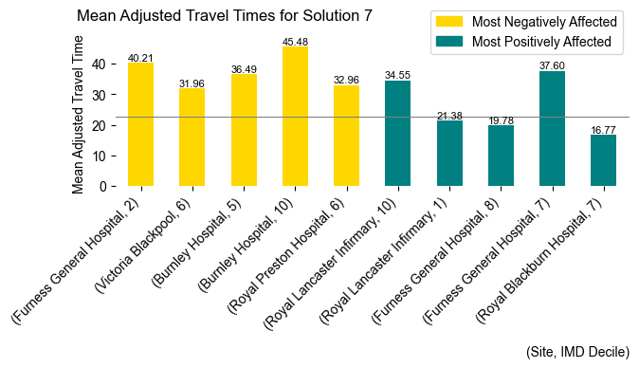

**Solution 8 Significant Deviations: Blackburn added as tier 3 Burnley removed.**

Site: Royal Blackburn Hospital

Adjusted Activity: 4460.00, Deviation: 35.60%

NICU Beds: 12.22, Deviation: 35.60%

Average travel time: 21.62 minutes, ranked 1 among all solutions.

Trend in IMD Deciles: Travel times are shorter at lower IMD deciles, correlation coefficient 0.47.

Top 5 most negatively affected IMD Deciles with Actual Times:

- Royal Blackburn Hospital in IMD decile 4 with a mean travel time of 22.67 minutes.

- Royal Lancaster Infirmary in IMD decile 7 with a mean travel time of 29.83 minutes.

- Royal Blackburn Hospital in IMD decile 1 with a mean travel time of 17.18 minutes.

- Royal Blackburn Hospital in IMD decile 6 with a mean travel time of 27.27 minutes.

- Royal Preston Hospital in IMD decile 10 with a mean travel time of 28.70 minutes.

Top 5 most positively affected IMD Deciles with Actual Times:

- Royal Lancaster Infirmary in IMD decile 10 with a mean travel time of 41.15 minutes.

- Royal Lancaster Infirmary in IMD decile 1 with a mean travel time of 22.86 minutes.

- Victoria Blackpool in IMD decile 8 with a mean travel time of 17.07 minutes.

- Furness General Hospital in IMD decile 8 with a mean travel time of 21.47 minutes.

- Royal Lancaster Infirmary in IMD decile 4 with a mean travel time of 7.46 minutes.

The difference from the overall mean is statistically significant (t-statistic = -2.67, p-value = 0.010).

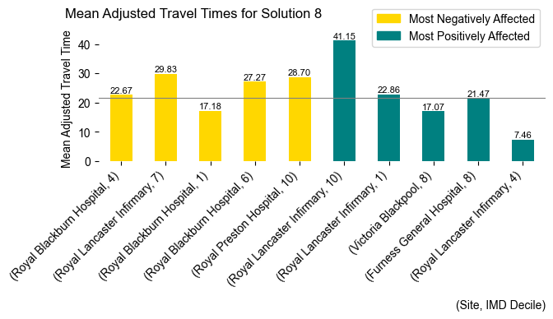

**Solution 9 Significant Deviations: Blackburn added as tier 3, Preston removed.**

Site: Burnley Hospital

Adjusted Activity: 2673.00, Deviation: -25.61%

NICU Beds: 7.32, Deviation: -25.60%

Average travel time: 23.93 minutes, ranked 4 among all solutions.

Trend in IMD Deciles: Travel times are shorter at lower IMD deciles, correlation coefficient 0.38.

Top 5 most negatively affected IMD Deciles with Actual Times:

- Furness General Hospital in IMD decile 8 with a mean travel time of 52.34 minutes.

- Furness General Hospital in IMD decile 4 with a mean travel time of 17.83 minutes.

- Furness General Hospital in IMD decile 9 with a mean travel time of 29.76 minutes.

- Royal Lancaster Infirmary in IMD decile 10 with a mean travel time of 60.24 minutes.

- Royal Blackburn Hospital in IMD decile 3 with a mean travel time of 21.38 minutes.

Top 5 most positively affected IMD Deciles with Actual Times:

- Victoria Blackpool in IMD decile 10 with a mean travel time of 34.69 minutes.

- Burnley Hospital in IMD decile 7 with a mean travel time of 17.91 minutes.

- Furness General Hospital in IMD decile 2 with a mean travel time of 13.71 minutes.

- Victoria Blackpool in IMD decile 6 with a mean travel time of 18.41 minutes.

- Burnley Hospital in IMD decile 10 with a mean travel time of 35.63 minutes.

The difference from the overall mean is statistically not significant (t-statistic = -0.82, p-value = 0.418).

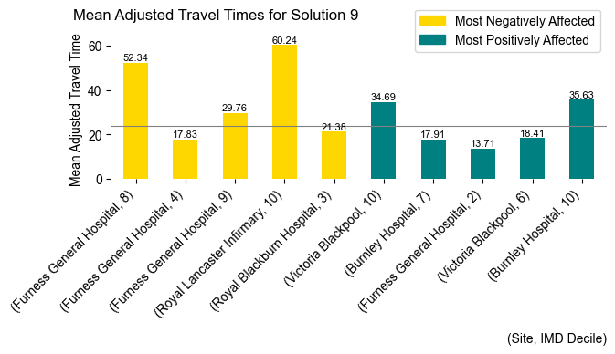

**Solution 10 Significant Deviations: Blackburn added as tier 3 and Preston and Burnley restricted to tier 1.**

Site: Burnley Hospital

Adjusted Activity: 959.00, Deviation: -73.31%

NICU Beds: 2.63, Deviation: -73.31%

Site: Royal Blackburn Hospital

Adjusted Activity: 4775.00, Deviation: 45.18%

NICU Beds: 13.08, Deviation: 45.16%

Site: Royal Preston Hospital

Adjusted Activity: 866.00, Deviation: -71.00%

NICU Beds: 2.37, Deviation: -71.01%

Average travel time: 24.15 minutes, ranked 5 among all solutions.

Trend in IMD Deciles: Travel times are shorter at lower IMD deciles, correlation coefficient 0.52.

Top 5 most negatively affected IMD Deciles with Actual Times:

- Furness General Hospital in IMD decile 2 with a mean travel time of 41.72 minutes.

- Royal Lancaster Infirmary in IMD decile 3 with a mean travel time of 37.96 minutes.

- Royal Blackburn Hospital in IMD decile 7 with a mean travel time of 32.55 minutes.

- Victoria Blackpool in IMD decile 8 with a mean travel time of 32.84 minutes.

- Royal Lancaster Infirmary in IMD decile 6 with a mean travel time of 43.69 minutes.

Top 5 most positively affected IMD Deciles with Actual Times:

- Royal Lancaster Infirmary in IMD decile 10 with a mean travel time of 33.65 minutes.

- Royal Preston Hospital in IMD decile 2 with a mean travel time of 29.61 minutes.

- Royal Preston Hospital in IMD decile 1 with a mean travel time of 28.11 minutes.

- Burnley Hospital in IMD decile 9 with a mean travel time of 20.93 minutes.

- Royal Preston Hospital in IMD decile 8 with a mean travel time of 27.70 minutes.

The difference from the overall mean is statistically not significant (t-statistic = -0.91, p-value = 0.364).

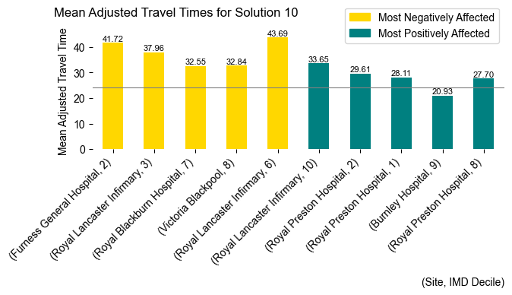

**Solution 32 Significant Deviations: Blackpool restricted to tier 1.**

Site: Furness General Hospital

Adjusted Activity: 68.00, Deviation: 28.68%

NICU Beds: 0.19, Deviation: 29.15%

Site: Royal Preston Hospital

Adjusted Activity: 4210.00, Deviation: 40.96%

NICU Beds: 11.54, Deviation: 40.96%

Site: Victoria Blackpool

Adjusted Activity: 333.00, Deviation: -44.31%

NICU Beds: 0.91, Deviation: -44.34%

Average travel time: 26.03 minutes, ranked 8 among all solutions.

Trend in IMD Deciles: Travel times are longer at lower IMD deciles, correlation coefficient -0.06.

Top 5 most negatively affected IMD Deciles with Actual Times:

- Royal Lancaster Infirmary in IMD decile 10 with a mean travel time of 79.28 minutes.

- Victoria Blackpool in IMD decile 8 with a mean travel time of 36.93 minutes.

- Royal Preston Hospital in IMD decile 8 with a mean travel time of 43.37 minutes.

- Royal Preston Hospital in IMD decile 1 with a mean travel time of 44.91 minutes.

- Burnley Hospital in IMD decile 10 with a mean travel time of 45.76 minutes.

Top 5 most positively affected IMD Deciles with Actual Times:

- Royal Lancaster Infirmary in IMD decile 4 with a mean travel time of 8.09 minutes.

- Royal Lancaster Infirmary in IMD decile 3 with a mean travel time of 14.19 minutes.

- Furness General Hospital in IMD decile 8 with a mean travel time of 26.43 minutes.

- Furness General Hospital in IMD decile 2 with a mean travel time of 15.32 minutes.

- Royal Lancaster Infirmary in IMD decile 6 with a mean travel time of 35.68 minutes.

The difference from the overall mean is statistically not significant (t-statistic = 0.44, p-value = 0.659).

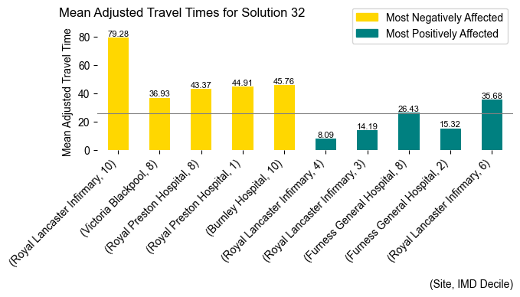

**Solution 33 Significant Deviations: Lancaster restricted to tier 1.**

Site: Burnley Hospital

Adjusted Activity: 4823.00, Deviation: 34.23%

NICU Beds: 13.22, Deviation: 34.23%

Site: Furness General Hospital

Adjusted Activity: 69.00, Deviation: 30.57%

NICU Beds: 0.19, Deviation: 30.56%

Average travel time: 25.35 minutes, ranked 6 among all solutions.

Trend in IMD Deciles: Travel times are shorter at lower IMD deciles, correlation coefficient 0.03.

Top 5 most negatively affected IMD Deciles with Actual Times:

- Victoria Blackpool in IMD decile 10 with a mean travel time of 67.90 minutes.

- Burnley Hospital in IMD decile 7 with a mean travel time of 38.02 minutes.

- Burnley Hospital in IMD decile 9 with a mean travel time of 39.70 minutes.

- Burnley Hospital in IMD decile 5 with a mean travel time of 37.45 minutes.

- Royal Lancaster Infirmary in IMD decile 1 with a mean travel time of 41.31 minutes.

Top 5 most positively affected IMD Deciles with Actual Times:

- Royal Lancaster Infirmary in IMD decile 10 with a mean travel time of 29.16 minutes.

- Furness General Hospital in IMD decile 8 with a mean travel time of 22.37 minutes.

- Furness General Hospital in IMD decile 7 with a mean travel time of 37.60 minutes.

- Royal Lancaster Infirmary in IMD decile 9 with a mean travel time of 24.55 minutes.

- Furness General Hospital in IMD decile 2 with a mean travel time of 15.66 minutes.

The difference from the overall mean is statistically not significant (t-statistic = 0.10, p-value = 0.919).

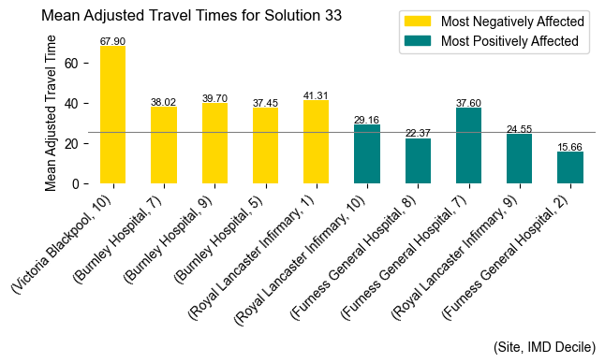

**Solution 34 Significant Deviations: Barrow removed.**

Site: Burnley Hospital

Adjusted Activity: 4963.00, Deviation: 38.13%

NICU Beds: 13.60, Deviation: 38.13%

Site: Royal Lancaster Infirmary

Adjusted Activity: 803.00, Deviation: 81.30%

NICU Beds: 2.20, Deviation: 81.24%

Average travel time: 31.68 minutes, ranked 14 among all solutions.

Trend in IMD Deciles: Travel times are longer at lower IMD deciles, correlation coefficient -0.50.

Top 5 most negatively affected IMD Deciles with Actual Times:

- Royal Lancaster Infirmary in IMD decile 10 with a mean travel time of 113.89 minutes.

- Royal Lancaster Infirmary in IMD decile 4 with a mean travel time of 45.05 minutes.

- Royal Lancaster Infirmary in IMD decile 1 with a mean travel time of 64.00 minutes.

- Royal Lancaster Infirmary in IMD decile 2 with a mean travel time of 44.66 minutes.

- Royal Lancaster Infirmary in IMD decile 5 with a mean travel time of 52.20 minutes.

Top 5 most positively affected IMD Deciles with Actual Times:

- Victoria Blackpool in IMD decile 8 with a mean travel time of 21.34 minutes.

- Victoria Blackpool in IMD decile 6 with a mean travel time of 18.50 minutes.

- Royal Preston Hospital in IMD decile 2 with a mean travel time of 37.59 minutes.

- Victoria Blackpool in IMD decile 3 with a mean travel time of 10.40 minutes.

- Burnley Hospital in IMD decile 9 with a mean travel time of 28.36 minutes.

The difference from the overall mean is statistically significant (t-statistic = 2.27, p-value = 0.029).

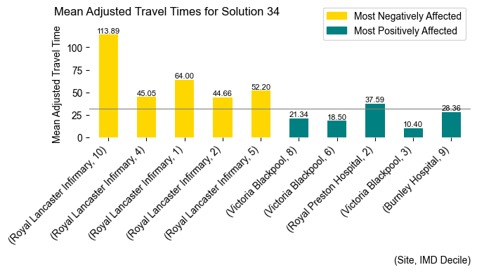

**Solution 35 Significant Deviations: Blackpool removed.**

Site: Burnley Hospital

Adjusted Activity: 4940.00, Deviation: 37.49%

NICU Beds: 13.54, Deviation: 37.49%

Site: Furness General Hospital

Adjusted Activity: 70.00, Deviation: 32.46%

NICU Beds: 0.19, Deviation: 31.97%

Site: Royal Preston Hospital

Adjusted Activity: 5060.00, Deviation: 69.42%

NICU Beds: 13.86, Deviation: 69.40%

Average travel time: 28.59 minutes, ranked 13 among all solutions.

Trend in IMD Deciles: Travel times are shorter at lower IMD deciles, correlation coefficient 0.34.

Top 5 most negatively affected IMD Deciles with Actual Times:

- Royal Lancaster Infirmary in IMD decile 3 with a mean travel time of 31.31 minutes.

- Royal Preston Hospital in IMD decile 1 with a mean travel time of 48.13 minutes.

- Royal Preston Hospital in IMD decile 2 with a mean travel time of 51.10 minutes.

- Royal Lancaster Infirmary in IMD decile 4 with a mean travel time of 26.82 minutes.

- Burnley Hospital in IMD decile 9 with a mean travel time of 40.74 minutes.

Top 5 most positively affected IMD Deciles with Actual Times:

- Royal Lancaster Infirmary in IMD decile 10 with a mean travel time of 38.09 minutes.

- Furness General Hospital in IMD decile 2 with a mean travel time of 14.49 minutes.

- Furness General Hospital in IMD decile 7 with a mean travel time of 39.80 minutes.

- Royal Lancaster Infirmary in IMD decile 5 with a mean travel time of 30.36 minutes.

- Furness General Hospital in IMD decile 10 with a mean travel time of 8.10 minutes.

The difference from the overall mean is statistically not significant (t-statistic = 1.98, p-value = 0.054).

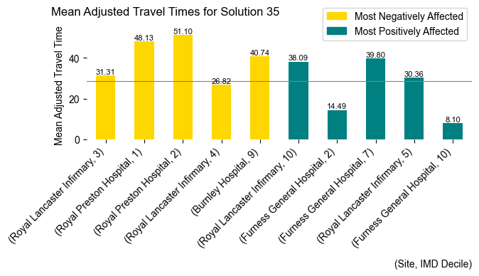

**Solution 36 Significant Deviations: Lancaster removed.**

Site: Burnley Hospital

Adjusted Activity: 4558.00, Deviation: 26.86%

NICU Beds: 12.49, Deviation: 26.86%

Site: Furness General Hospital

Adjusted Activity: 77.00, Deviation: 45.71%

NICU Beds: 0.21, Deviation: 45.59%

Site: Royal Preston Hospital

Adjusted Activity: 4135.00, Deviation: 38.45%

NICU Beds: 11.33, Deviation: 38.43%

Average travel time: 26.08 minutes, ranked 9 among all solutions.

Trend in IMD Deciles: Travel times are longer at lower IMD deciles, correlation coefficient -0.02.

Top 5 most negatively affected IMD Deciles with Actual Times:

- Burnley Hospital in IMD decile 10 with a mean travel time of 60.04 minutes.

- Royal Preston Hospital in IMD decile 6 with a mean travel time of 44.11 minutes.

- Furness General Hospital in IMD decile 8 with a mean travel time of 46.73 minutes.

- Royal Preston Hospital in IMD decile 2 with a mean travel time of 54.70 minutes.

- Furness General Hospital in IMD decile 5 with a mean travel time of 19.20 minutes.

Top 5 most positively affected IMD Deciles with Actual Times:

- Furness General Hospital in IMD decile 2 with a mean travel time of 12.84 minutes.

- Burnley Hospital in IMD decile 5 with a mean travel time of 24.27 minutes.

- Victoria Blackpool in IMD decile 8 with a mean travel time of 21.55 minutes.

- Victoria Blackpool in IMD decile 6 with a mean travel time of 17.88 minutes.

- Burnley Hospital in IMD decile 9 with a mean travel time of 29.05 minutes.

The difference from the overall mean is statistically not significant (t-statistic = 0.43, p-value = 0.671).

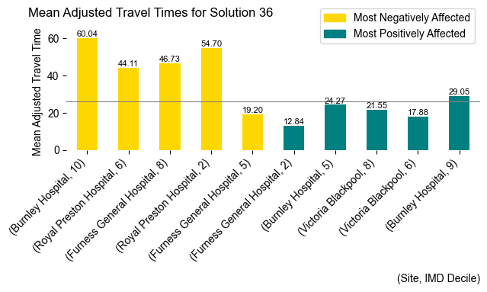

# Greater Manchester Health and Social Care Partnership

**Solution 11 Significant Deviations: Tameside restricted to tier 1.**

Site: Royal Oldham Hospital

Adjusted Activity: 4766.00, Deviation: 22.20%

NICU Beds: 13.06, Deviation: 22.20%

Site: Tameside General Hospital

Adjusted Activity: 111.00, Deviation: -69.03%

NICU Beds: 0.31, Deviation: -68.92%

Average travel time: 20.97 minutes, ranked 1 among all solutions.

Trend in IMD Deciles: Travel times are shorter at lower IMD deciles, correlation coefficient 0.13.

Top 5 most negatively affected IMD Deciles with Actual Times:

- Royal Oldham Hospital in IMD decile 10 with a mean travel time of 52.39 minutes.

- MFT - St Mary’s Hospital in IMD decile 6 with a mean travel time of 42.76 minutes.

- MFT - St Mary’s Hospital in IMD decile 5 with a mean travel time of 42.51 minutes.

- MFT - North Manchester General Hospital in IMD decile 10 with a mean travel time of 37.31 minutes.

- MFT - St Mary’s Hospital in IMD decile 4 with a mean travel time of 28.50 minutes.

Top 5 most positively affected IMD Deciles with Actual Times:

- MFT - St Mary’s Hospital in IMD decile 8 with a mean travel time of 45.85 minutes.

- Tameside General Hospital in IMD decile 7 with a mean travel time of 17.06 minutes.

- Tameside General Hospital in IMD decile 6 with a mean travel time of 23.36 minutes.

- Royal Oldham Hospital in IMD decile 8 with a mean travel time of 24.28 minutes.

- Royal Oldham Hospital in IMD decile 9 with a mean travel time of 28.75 minutes.

The difference from the overall mean is statistically not significant (t-statistic = -1.11, p-value = 0.272).

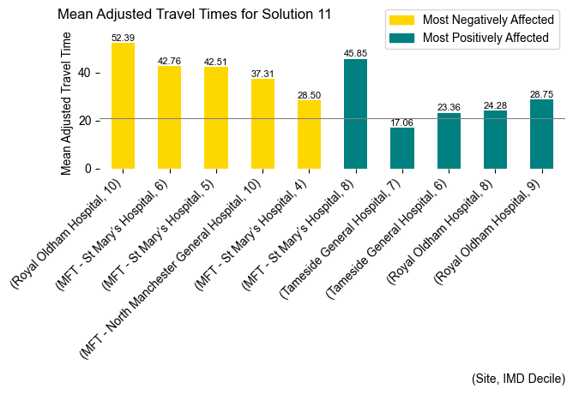

**Solution 12 Significant Deviations: Bolton restricted to tier 1.**

Site: MFT - North Manchester General Hospital

Adjusted Activity: 553.00, Deviation: 20.67%

NICU Beds: 1.52, Deviation: 20.74%

Site: Royal Albert Edward Infirmary

Adjusted Activity: 607.00, Deviation: 37.90%

NICU Beds: 1.66, Deviation: 37.76%

Site: Royal Bolton Hospital

Adjusted Activity: 810.00, Deviation: -77.57%

NICU Beds: 2.22, Deviation: -77.57%

Site: Royal Oldham Hospital

Adjusted Activity: 4533.00, Deviation: 16.23%

NICU Beds: 12.42, Deviation: 16.22%

Average travel time: 23.36 minutes, ranked 11 among all solutions.

Trend in IMD Deciles: Travel times are shorter at lower IMD deciles, correlation coefficient 0.46.

Top 5 most negatively affected IMD Deciles with Actual Times:

- MFT - St Mary’s Hospital in IMD decile 5 with a mean travel time of 54.43 minutes.

- Tameside General Hospital in IMD decile 6 with a mean travel time of 47.95 minutes.

- MFT - North Manchester General Hospital in IMD decile 8 with a mean travel time of 47.64 minutes.

- Tameside General Hospital in IMD decile 7 with a mean travel time of 38.00 minutes.

- Tameside General Hospital in IMD decile 9 with a mean travel time of 39.90 minutes.

Top 5 most positively affected IMD Deciles with Actual Times:

- MFT - St Mary’s Hospital in IMD decile 8 with a mean travel time of 47.77 minutes.

- Royal Oldham Hospital in IMD decile 10 with a mean travel time of 35.42 minutes.

- MFT - St Mary’s Hospital in IMD decile 7 with a mean travel time of 31.33 minutes.

- Royal Bolton Hospital in IMD decile 5 with a mean travel time of 19.11 minutes.

- Royal Bolton Hospital in IMD decile 8 with a mean travel time of 21.18 minutes.

The difference from the overall mean is statistically not significant (t-statistic = 1.25, p-value = 0.215).

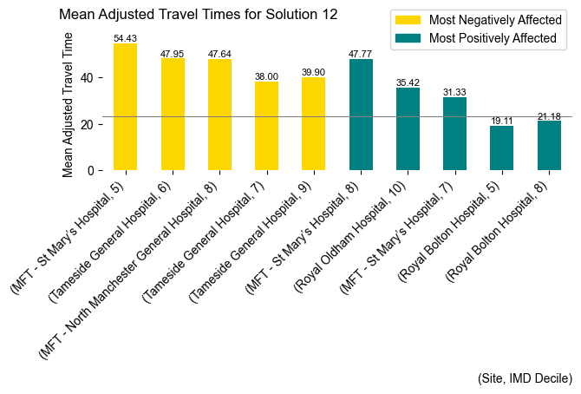

**Solution 13 Significant Deviations: Wigan (Royal Albert) restricted to tier 1.**

Site: Royal Albert Edward Infirmary

Adjusted Activity: 174.00, Deviation: -60.47%

NICU Beds: 0.48, Deviation: -60.34%

Site: Royal Bolton Hospital

Adjusted Activity: 4341.00, Deviation: 20.21%

NICU Beds: 11.90, Deviation: 20.21%

Site: Tameside General Hospital

Adjusted Activity: 301.00, Deviation: -16.01%

NICU Beds: 0.83, Deviation: -15.96%

Average travel time: 21.85 minutes, ranked 6 among all solutions.

Trend in IMD Deciles: Travel times are shorter at lower IMD deciles, correlation coefficient 0.41.

Top 5 most negatively affected IMD Deciles with Actual Times:

- MFT - St Mary’s Hospital in IMD decile 8 with a mean travel time of 87.62 minutes.

- MFT - St Mary’s Hospital in IMD decile 7 with a mean travel time of 43.64 minutes.

- Royal Oldham Hospital in IMD decile 8 with a mean travel time of 38.91 minutes.

- MFT - North Manchester General Hospital in IMD decile 9 with a mean travel time of 25.77 minutes.

- Tameside General Hospital in IMD decile 7 with a mean travel time of 31.44 minutes.

Top 5 most positively affected IMD Deciles with Actual Times:

- Stepping Hill Hospital in IMD decile 3 with a mean travel time of 11.58 minutes.

- MFT - St Mary’s Hospital in IMD decile 5 with a mean travel time of 29.64 minutes.

- Royal Albert Edward Infirmary in IMD decile 1 with a mean travel time of 8.45 minutes.

- MFT - St Mary’s Hospital in IMD decile 6 with a mean travel time of 31.03 minutes.

- Royal Albert Edward Infirmary in IMD decile 7 with a mean travel time of 11.60 minutes.

The difference from the overall mean is statistically not significant (t-statistic = -0.17, p-value = 0.866).

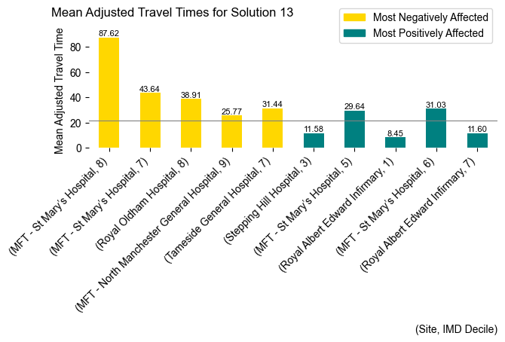

**Solution 14 Significant Deviations: St Marys (MFT) restricted to tier 1.**

Site: MFT - St Mary’s Hospital

Adjusted Activity: 2291.00, Deviation: -77.93%

NICU Beds: 6.28, Deviation: -77.93%

Site: MFT - Wythenshawe Hospital

Adjusted Activity: 955.00, Deviation: 31.66%

NICU Beds: 2.62, Deviation: 31.62%

Average travel time: 21.38 minutes, ranked 3 among all solutions.

Trend in IMD Deciles: Travel times are shorter at lower IMD deciles, correlation coefficient 0.28.

Top 5 most negatively affected IMD Deciles with Actual Times:

- MFT - St Mary’s Hospital in IMD decile 8 with a mean travel time of 65.94 minutes.

- Royal Albert Edward Infirmary in IMD decile 10 with a mean travel time of 31.79 minutes.

- Royal Oldham Hospital in IMD decile 8 with a mean travel time of 35.35 minutes.

- Royal Albert Edward Infirmary in IMD decile 7 with a mean travel time of 18.67 minutes.

- Tameside General Hospital in IMD decile 4 with a mean travel time of 20.83 minutes.

Top 5 most positively affected IMD Deciles with Actual Times:

- MFT - St Mary’s Hospital in IMD decile 7 with a mean travel time of 20.05 minutes.

- MFT - St Mary’s Hospital in IMD decile 5 with a mean travel time of 26.36 minutes.

- MFT - St Mary’s Hospital in IMD decile 1 with a mean travel time of 18.95 minutes.

- Tameside General Hospital in IMD decile 9 with a mean travel time of 22.78 minutes.

- Royal Oldham Hospital in IMD decile 10 with a mean travel time of 37.37 minutes.

The difference from the overall mean is statistically not significant (t-statistic = -0.73, p-value = 0.470).

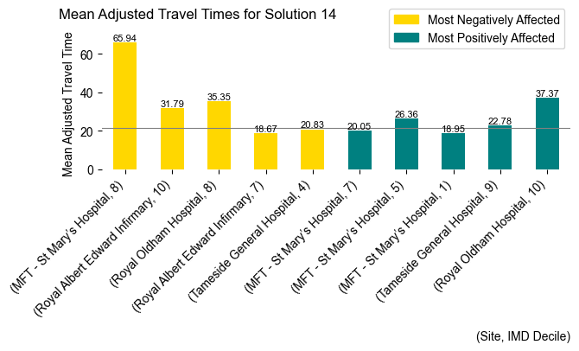

**Solution 15 Significant Deviations: Oldham restricted to tier 1.**

Site: MFT - North Manchester General Hospital

Adjusted Activity: 543.00, Deviation: 18.49%

NICU Beds: 1.49, Deviation: 18.39%

Site: Royal Oldham Hospital

Adjusted Activity: 832.00, Deviation: -78.67%

NICU Beds: 2.28, Deviation: -78.66%

Site: Tameside General Hospital

Adjusted Activity: 529.00, Deviation: 47.62%

NICU Beds: 1.45, Deviation: 47.60%

Average travel time: 21.72 minutes, ranked 5 among all solutions.

Trend in IMD Deciles: Travel times are shorter at lower IMD deciles, correlation coefficient 0.28.

Top 5 most negatively affected IMD Deciles with Actual Times:

- Royal Albert Edward Infirmary in IMD decile 10 with a mean travel time of 35.59 minutes.

- MFT - St Mary’s Hospital in IMD decile 7 with a mean travel time of 44.06 minutes.

- Tameside General Hospital in IMD decile 8 with a mean travel time of 25.83 minutes.

- MFT - St Mary’s Hospital in IMD decile 2 with a mean travel time of 33.45 minutes.

- Royal Bolton Hospital in IMD decile 7 with a mean travel time of 22.23 minutes.

Top 5 most positively affected IMD Deciles with Actual Times:

- Royal Oldham Hospital in IMD decile 7 with a mean travel time of 7.32 minutes.

- Royal Oldham Hospital in IMD decile 9 with a mean travel time of 22.46 minutes.

- MFT - St Mary’s Hospital in IMD decile 10 with a mean travel time of 33.54 minutes.

- MFT - North Manchester General Hospital in IMD decile 10 with a mean travel time of 27.55 minutes.

- MFT - St Mary’s Hospital in IMD decile 8 with a mean travel time of 54.30 minutes.

The difference from the overall mean is statistically not significant (t-statistic = -0.39, p-value = 0.695).

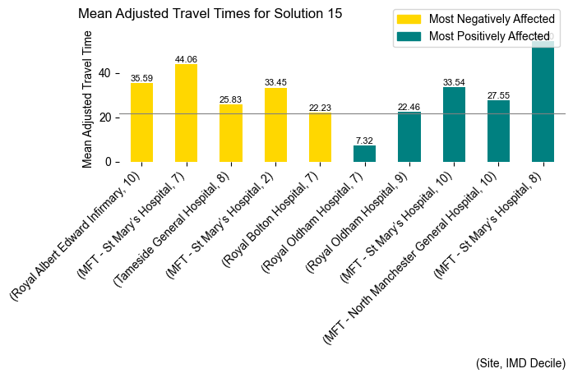

**Solution 16 Significant Deviations: Leighton restricted to tier 1.**

Site: MFT - North Manchester General Hospital

Adjusted Activity: 368.00, Deviation: -19.70%

NICU Beds: 1.01, Deviation: -19.60%

Average travel time: 21.20 minutes, ranked 2 among all solutions.

Trend in IMD Deciles: Travel times are shorter at lower IMD deciles, correlation coefficient 0.12.

Top 5 most negatively affected IMD Deciles with Actual Times:

- MFT - North Manchester General Hospital in IMD decile 10 with a mean travel time of 43.27 minutes.

- MFT - North Manchester General Hospital in IMD decile 8 with a mean travel time of 40.53 minutes.

- Tameside General Hospital in IMD decile 10 with a mean travel time of 41.27 minutes.

- Royal Albert Edward Infirmary in IMD decile 4 with a mean travel time of 27.80 minutes.

- MFT - North Manchester General Hospital in IMD decile 7 with a mean travel time of 25.84 minutes.

Top 5 most positively affected IMD Deciles with Actual Times:

- MFT - St Mary’s Hospital in IMD decile 8 with a mean travel time of 37.69 minutes.

- Tameside General Hospital in IMD decile 6 with a mean travel time of 14.45 minutes.

- Royal Albert Edward Infirmary in IMD decile 10 with a mean travel time of 19.09 minutes.

- Tameside General Hospital in IMD decile 8 with a mean travel time of 12.14 minutes.

- Tameside General Hospital in IMD decile 7 with a mean travel time of 21.64 minutes.

The difference from the overall mean is statistically not significant (t-statistic = -0.89, p-value = 0.374).

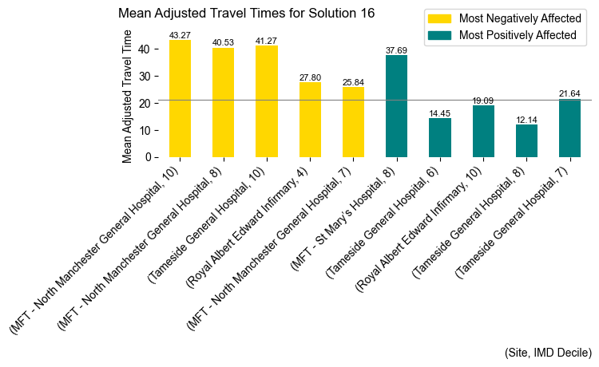

**Solution 26 Significant Deviations: Bolton restricted to tier 2.**

Site: MFT - North Manchester General Hospital

Adjusted Activity: 566.00, Deviation: 23.51%

NICU Beds: 1.55, Deviation: 23.41%

Site: Royal Albert Edward Infirmary

Adjusted Activity: 569.00, Deviation: 29.26%

NICU Beds: 1.56, Deviation: 29.25%

Site: Royal Bolton Hospital

Adjusted Activity: 1246.00, Deviation: -65.50%

NICU Beds: 3.42, Deviation: -65.48%

Site: Royal Oldham Hospital

Adjusted Activity: 4985.00, Deviation: 27.81%

NICU Beds: 13.66, Deviation: 27.82%

Average travel time: 23.31 minutes, ranked 10 among all solutions.

Trend in IMD Deciles: Travel times are shorter at lower IMD deciles, correlation coefficient 0.42.

Top 5 most negatively affected IMD Deciles with Actual Times:

- MFT - St Mary’s Hospital in IMD decile 8 with a mean travel time of 89.31 minutes.

- Royal Oldham Hospital in IMD decile 8 with a mean travel time of 42.92 minutes.

- Stepping Hill Hospital in IMD decile 9 with a mean travel time of 25.95 minutes.

- Royal Oldham Hospital in IMD decile 9 with a mean travel time of 43.42 minutes.

- MFT - North Manchester General Hospital in IMD decile 9 with a mean travel time of 27.39 minutes.

Top 5 most positively affected IMD Deciles with Actual Times:

- MFT - St Mary’s Hospital in IMD decile 5 with a mean travel time of 31.19 minutes.

- Royal Oldham Hospital in IMD decile 10 with a mean travel time of 39.23 minutes.

- Royal Bolton Hospital in IMD decile 6 with a mean travel time of 16.37 minutes.

- Royal Bolton Hospital in IMD decile 1 with a mean travel time of 16.33 minutes.

- Royal Bolton Hospital in IMD decile 8 with a mean travel time of 21.57 minutes.

The difference from the overall mean is statistically not significant (t-statistic = 1.02, p-value = 0.309).

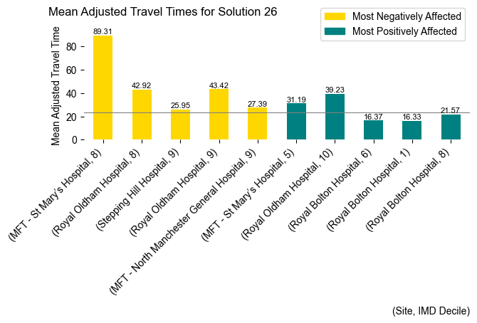

**Solution 27 Significant Deviations: Oldham restricted to tier 2.**

Site: MFT - North Manchester General Hospital

Adjusted Activity: 604.00, Deviation: 31.80%

NICU Beds: 1.66, Deviation: 31.86%

Site: MFT - Wythenshawe Hospital

Adjusted Activity: 842.00, Deviation: 16.08%

NICU Beds: 2.31, Deviation: 16.12%

Site: Royal Oldham Hospital

Adjusted Activity: 1338.00, Deviation: -65.69%

NICU Beds: 3.67, Deviation: -65.70%

Site: Stepping Hill Hospital

Adjusted Activity: 488.00, Deviation: 18.58%

NICU Beds: 1.34, Deviation: 18.65%

Site: Tameside General Hospital

Adjusted Activity: 521.00, Deviation: 45.38%

NICU Beds: 1.43, Deviation: 45.23%

Average travel time: 22.15 minutes, ranked 8 among all solutions.

Trend in IMD Deciles: Travel times are shorter at lower IMD deciles, correlation coefficient 0.42.

Top 5 most negatively affected IMD Deciles with Actual Times:

- Royal Oldham Hospital in IMD decile 7 with a mean travel time of 36.77 minutes.

- Tameside General Hospital in IMD decile 8 with a mean travel time of 27.82 minutes.

- MFT - St Mary’s Hospital in IMD decile 5 with a mean travel time of 41.70 minutes.

- MFT - St Mary’s Hospital in IMD decile 6 with a mean travel time of 40.33 minutes.

- Stepping Hill Hospital in IMD decile 10 with a mean travel time of 16.71 minutes.

Top 5 most positively affected IMD Deciles with Actual Times:

- Royal Oldham Hospital in IMD decile 6 with a mean travel time of 21.60 minutes.

- Royal Oldham Hospital in IMD decile 8 with a mean travel time of 22.02 minutes.

- Royal Oldham Hospital in IMD decile 4 with a mean travel time of 19.00 minutes.

- MFT - North Manchester General Hospital in IMD decile 10 with a mean travel time of 28.04 minutes.

- Royal Oldham Hospital in IMD decile 9 with a mean travel time of 31.02 minutes.

The difference from the overall mean is statistically not significant (t-statistic = 0.09, p-value = 0.930).

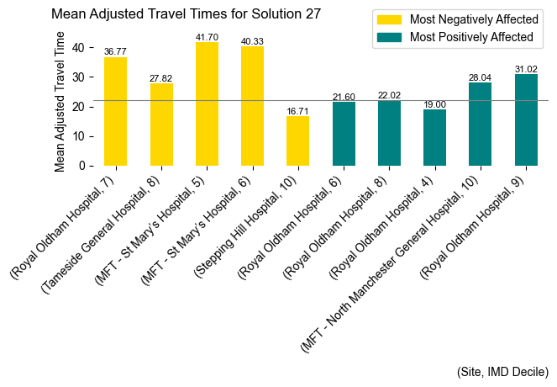

**Solution 28 Significant Deviations: Whythenshaw restricted to tier 1.**

Site: MFT - St Mary’s Hospital

Adjusted Activity: 12624.00, Deviation: 21.60%

NICU Beds: 34.59, Deviation: 21.60%

Site: MFT - Wythenshawe Hospital

Adjusted Activity: 221.00, Deviation: -69.53%

NICU Beds: 0.61, Deviation: -69.51%

Site: Royal Bolton Hospital

Adjusted Activity: 4398.00, Deviation: 21.79%

NICU Beds: 12.05, Deviation: 21.77%

Site: Stepping Hill Hospital

Adjusted Activity: 562.00, Deviation: 36.56%

NICU Beds: 1.54, Deviation: 36.43%

Average travel time: 21.96 minutes, ranked 7 among all solutions.

Trend in IMD Deciles: Travel times are shorter at lower IMD deciles, correlation coefficient 0.47.

Top 5 most negatively affected IMD Deciles with Actual Times:

- Royal Oldham Hospital in IMD decile 9 with a mean travel time of 59.16 minutes.

- Tameside General Hospital in IMD decile 9 with a mean travel time of 38.98 minutes.

- Royal Oldham Hospital in IMD decile 6 with a mean travel time of 38.30 minutes.

- Tameside General Hospital in IMD decile 8 with a mean travel time of 25.29 minutes.

- MFT - North Manchester General Hospital in IMD decile 6 with a mean travel time of 30.21 minutes.

Top 5 most positively affected IMD Deciles with Actual Times:

- MFT - St Mary’s Hospital in IMD decile 8 with a mean travel time of 46.07 minutes.

- Royal Oldham Hospital in IMD decile 10 with a mean travel time of 34.90 minutes.

- MFT - St Mary’s Hospital in IMD decile 10 with a mean travel time of 33.78 minutes.

- Royal Oldham Hospital in IMD decile 8 with a mean travel time of 25.51 minutes.

- MFT - Wythenshawe Hospital in IMD decile 2 with a mean travel time of 12.74 minutes.

The difference from the overall mean is statistically not significant (t-statistic = -0.10, p-value = 0.918).

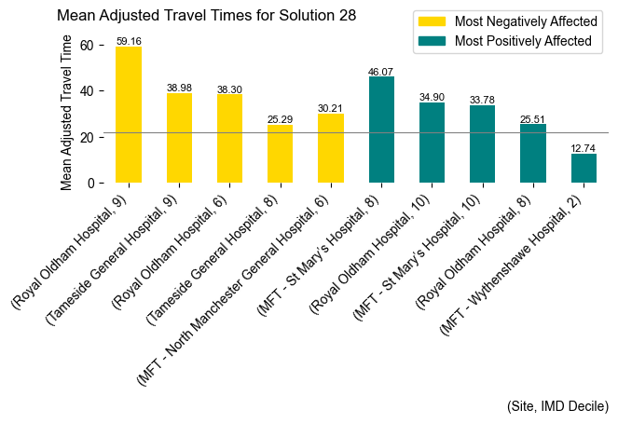

**Solution 29 Significant Deviations: North Manchester restricted to tier 1.**

Site: MFT - North Manchester General Hospital

Adjusted Activity: 96.00, Deviation: -79.05%

NICU Beds: 0.26, Deviation: -79.01%

Site: MFT - St Mary’s Hospital

Adjusted Activity: 13292.00, Deviation: 28.04%

NICU Beds: 36.42, Deviation: 28.03%

Site: Royal Bolton Hospital

Adjusted Activity: 4458.00, Deviation: 23.45%

NICU Beds: 12.22, Deviation: 23.44%

Site: Royal Oldham Hospital

Adjusted Activity: 5492.00, Deviation: 40.81%

NICU Beds: 15.05, Deviation: 40.81%

Average travel time: 22.19 minutes, ranked 9 among all solutions.

Trend in IMD Deciles: Travel times are shorter at lower IMD deciles, correlation coefficient 0.21.

Top 5 most negatively affected IMD Deciles with Actual Times:

- MFT - St Mary’s Hospital in IMD decile 10 with a mean travel time of 53.75 minutes.

- Royal Oldham Hospital in IMD decile 10 with a mean travel time of 53.57 minutes.

- MFT - St Mary’s Hospital in IMD decile 9 with a mean travel time of 36.84 minutes.

- Royal Oldham Hospital in IMD decile 8 with a mean travel time of 35.78 minutes.

- Stepping Hill Hospital in IMD decile 5 with a mean travel time of 16.40 minutes.

Top 5 most positively affected IMD Deciles with Actual Times:

- MFT - North Manchester General Hospital in IMD decile 8 with a mean travel time of 18.80 minutes.

- MFT - North Manchester General Hospital in IMD decile 9 with a mean travel time of 13.98 minutes.

- MFT - North Manchester General Hospital in IMD decile 10 with a mean travel time of 26.00 minutes.

- MFT - North Manchester General Hospital in IMD decile 3 with a mean travel time of 10.55 minutes.

- MFT - North Manchester General Hospital in IMD decile 1 with a mean travel time of 7.67 minutes.

The difference from the overall mean is statistically not significant (t-statistic = 0.12, p-value = 0.908).

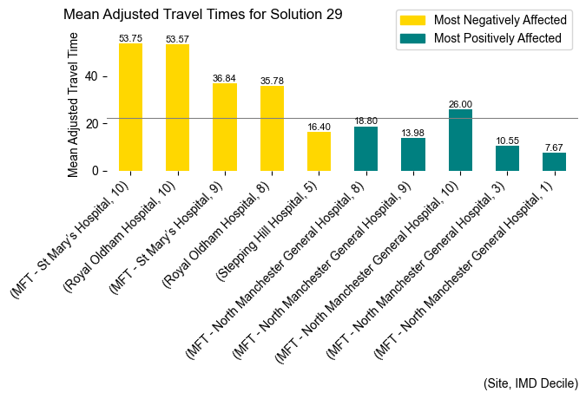

**Solution 30 Significant Deviations: Stepping Hill restricted to tier 1.**

Site: MFT - St Mary’s Hospital

Adjusted Activity: 12528.00, Deviation: 20.68%

NICU Beds: 34.33, Deviation: 20.68%

Site: Stepping Hill Hospital

Adjusted Activity: 179.00, Deviation: -56.51%

NICU Beds: 0.49, Deviation: -56.55%

Average travel time: 21.52 minutes, ranked 4 among all solutions.

Trend in IMD Deciles: Travel times are shorter at lower IMD deciles, correlation coefficient 0.23.

Top 5 most negatively affected IMD Deciles with Actual Times:

- Tameside General Hospital in IMD decile 6 with a mean travel time of 44.79 minutes.

- Royal Oldham Hospital in IMD decile 10 with a mean travel time of 50.91 minutes.

- MFT - North Manchester General Hospital in IMD decile 8 with a mean travel time of 39.11 minutes.

- MFT - North Manchester General Hospital in IMD decile 10 with a mean travel time of 36.02 minutes.

- Tameside General Hospital in IMD decile 9 with a mean travel time of 32.20 minutes.

Top 5 most positively affected IMD Deciles with Actual Times:

- MFT - St Mary’s Hospital in IMD decile 9 with a mean travel time of 22.99 minutes.

- Stepping Hill Hospital in IMD decile 5 with a mean travel time of 5.34 minutes.

- Royal Oldham Hospital in IMD decile 9 with a mean travel time of 29.89 minutes.

- Tameside General Hospital in IMD decile 8 with a mean travel time of 14.69 minutes.

- Royal Oldham Hospital in IMD decile 8 with a mean travel time of 26.48 minutes.

The difference from the overall mean is statistically not significant (t-statistic = -0.51, p-value = 0.613).

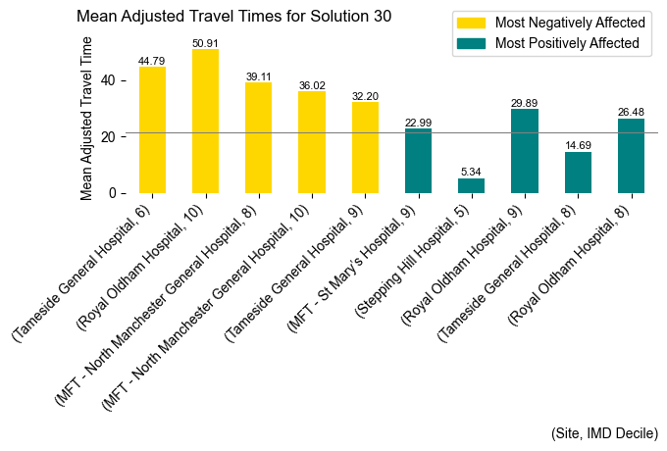

# Cross-Border Considerations in Holistic Analysis

A critical aspect of a comprehensive analysis of our results involves examining cross-border limitations and issues that have arisen. Certain site objectives have prompted an increased flow of activities between regions, necessitating cautious interpretation and enhanced engagement with regional commissioners and the sites receiving this redirected activity.

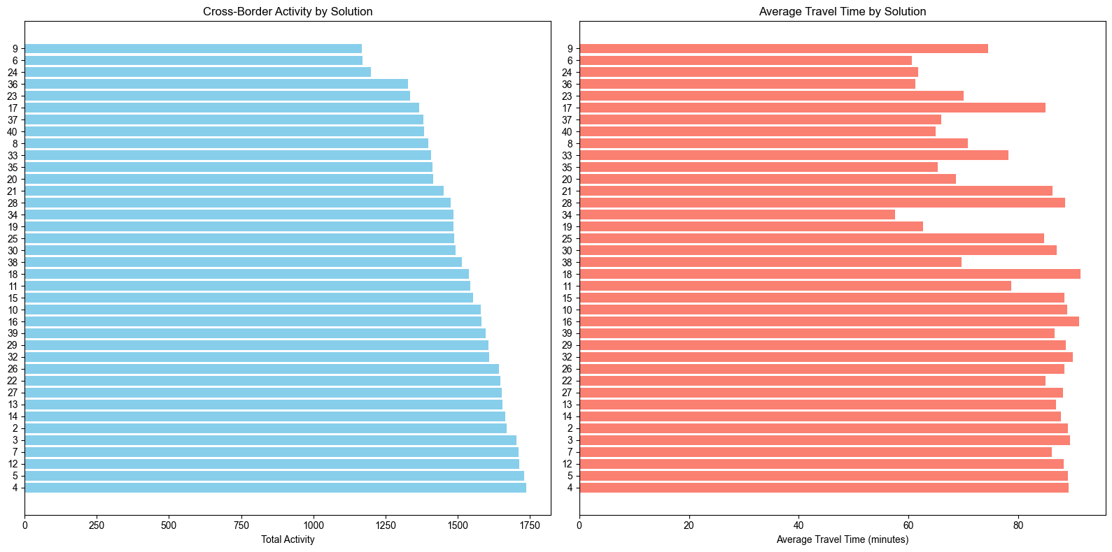

It is advisable to minimize these cross-border flows where feasible, as they are consistently associated with longer travel times, and reducing them could generally benefit the system.

It is important to note that our modelling was conducted without access to comprehensive out-of-area data. We only possessed out-of-area data where activities were undertaken by providers in the North West. For our site analysis, this data was excluded because the North West is a known importer of activity from other regions, making it prudent to model only resident North West activity. However, when utilising these results for decision support, significant further investigation is necessary, particularly concerning solution objectives that involve sites on the periphery of the North West region.

# Summary Conclusion

This research employed advanced evolutionary algorithms to address complex logistical challenges within healthcare site configurations, focusing primarily on the optimisation of NICU activities across the North West region. By using genetic algorithms and evolutionary strategies, we were able to explore a myriad of potential solutions within a computationally challenging environment, identifying configurations that potentially enhance service delivery while balancing a range of competing priorities.

The core findings indicate a pronounced tendency for the algorithm to distribute healthcare activities more evenly across available sites, diverging from current centralisations. This redistribution aims to align healthcare services closer to patient home locations, potentially reducing travel times and improving access to care. However, despite enhancements in smaller sites, many still fell short of reaching the BAPM standards for Level 3 units, highlighting a critical area for further adjustment and consideration.

Cross-border activity flow emerged as a significant concern, with the algorithm occasionally promoting increased activity across regional lines, which may not always be desirable due to longer associated travel times and regional healthcare management complexities. It is crucial that these findings are not interpreted in isolation but are used as a supplementary tool within broader decision-making processes involving direct consultations with regional healthcare authorities and commissioners.

The research acknowledges its limitations, notably the absence of comprehensive out-of-area data which could impact the generalizability of the findings. Therefore, while the modelling provides valuable insights and a robust framework for assessing potential changes in NICU site configurations, any practical application of these results must be approached with caution, requiring extensive validation and adaptation to specific local contexts.

Further research is recommended to incorporate a wider scope of data and to refine the evolutionary algorithms based on real-world feedback and evolving healthcare standards.